### TITLE; SENSOR NAME Software Full Regression Tests

TESTER;

DATES;

SYSTEMS USED;

* Name Network Controller on 915, Software version SESPLY_CSP_22_07_20, CHANNEL XXX
* Name Network Controller on 868, Software version SESPLY_CSP_22_07_20, CHANNEL XXX

SENSORS USED;

* SENSOR
  + SERIAL NUMBER 1
  + SERIAL NUMBER 2

TEST SW CXXX

PRODUCTION SW CXXX

REGRESSION TEST PLAN

TEST CASE 1.1 SET-UP - Device installs correctly – RV

Load most recent *Logger Image File* on Rabbit Viewer

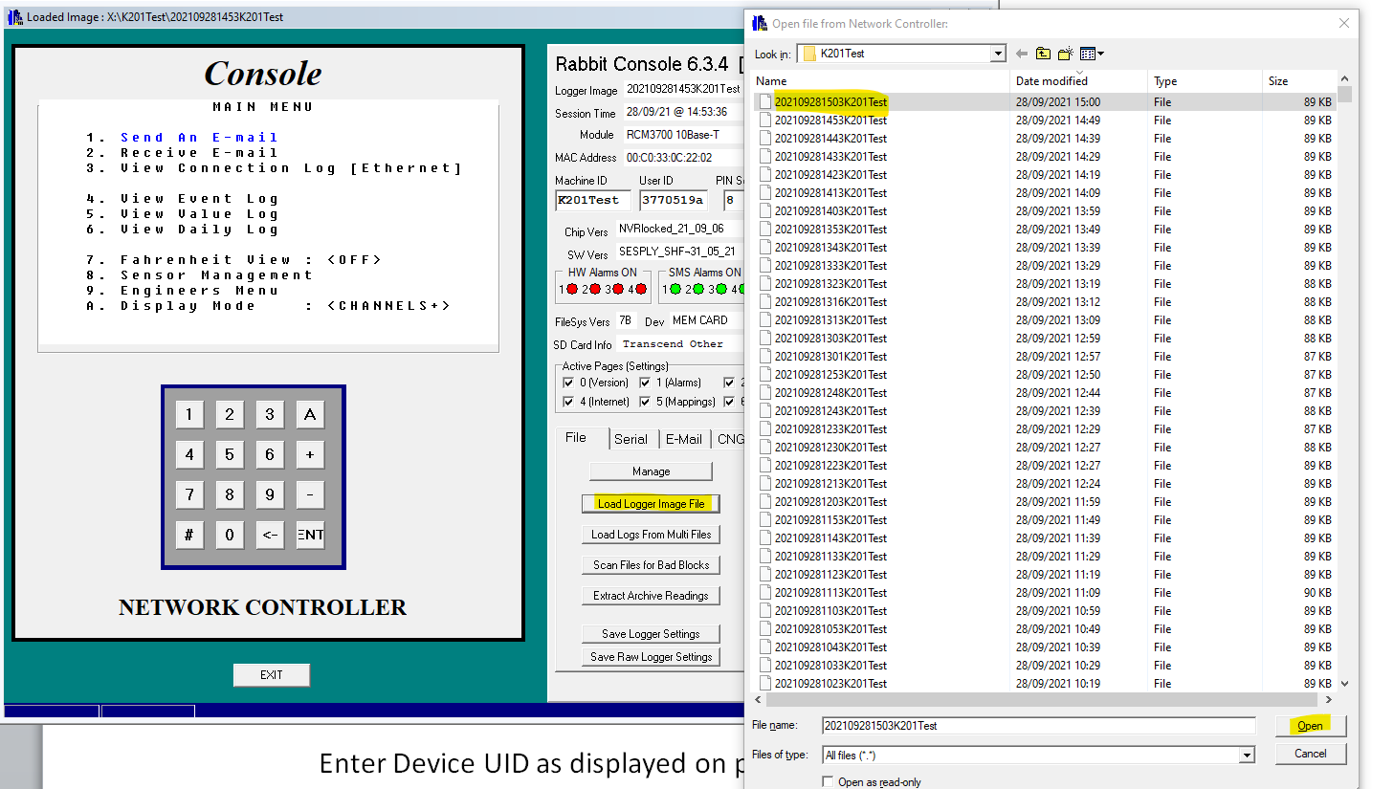

Open *Slave Network* tab

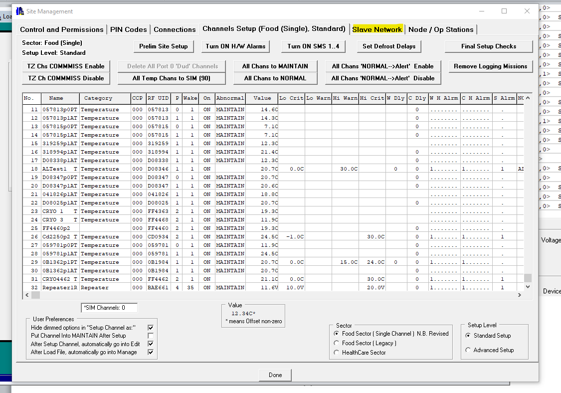

Click *Install New Devices* button

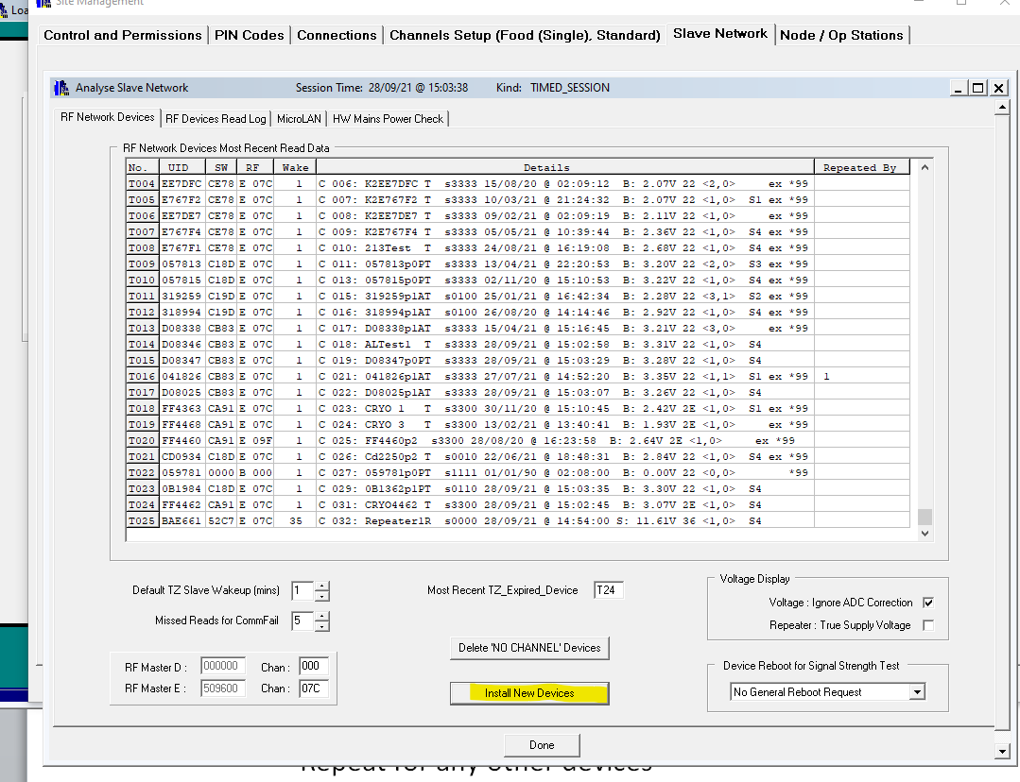

Select *New TZ Device Type*

Enter Device UID as displayed on physical sensor

Click *Install* button

Repeat for any other devices

Click *All Done* button

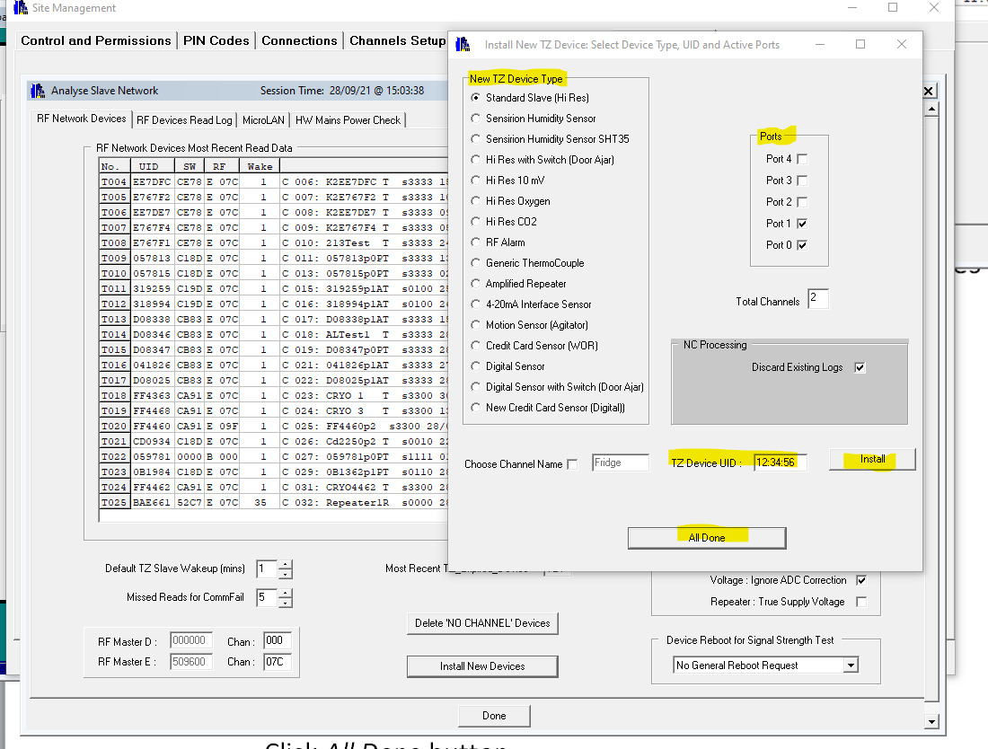

Ensure *Success* pop-up box appears and click *OK*

Ensure device is listed in Slave Network screen and click *Done*

Ensure device is listed in Site Management screen correctly and click *Done*

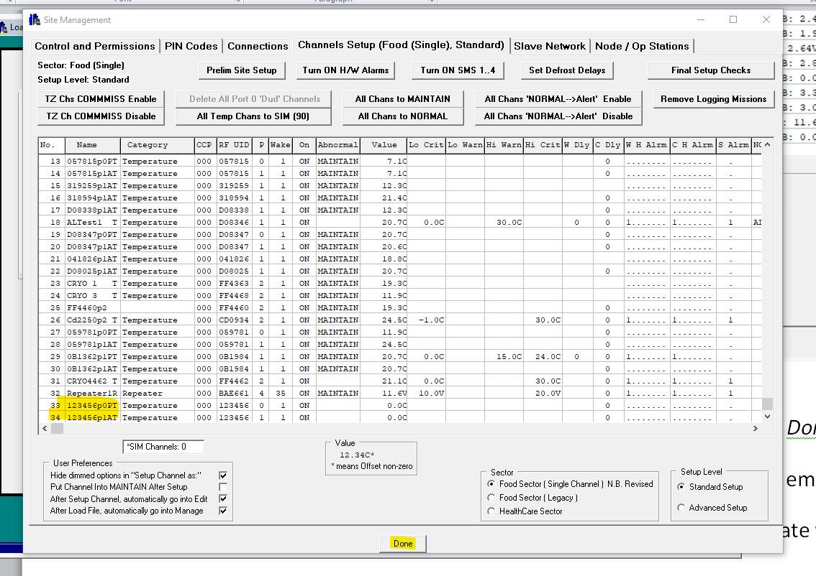

Build Change File, save in relevant folder and send to RV as email attachment

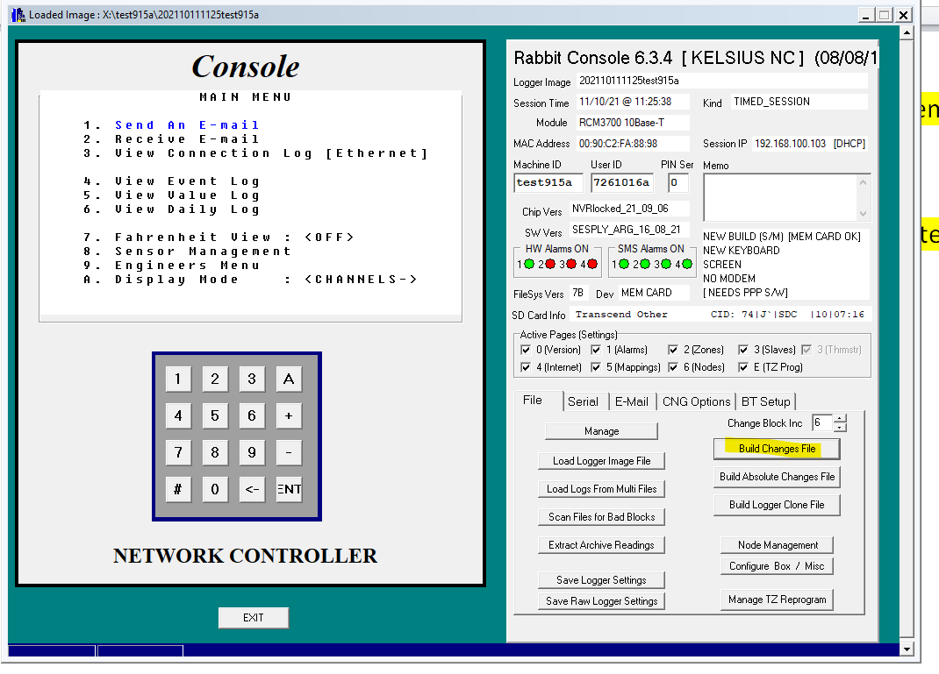

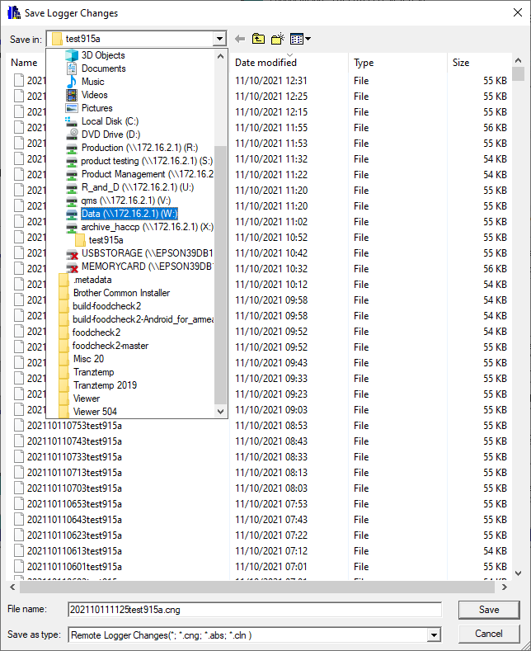

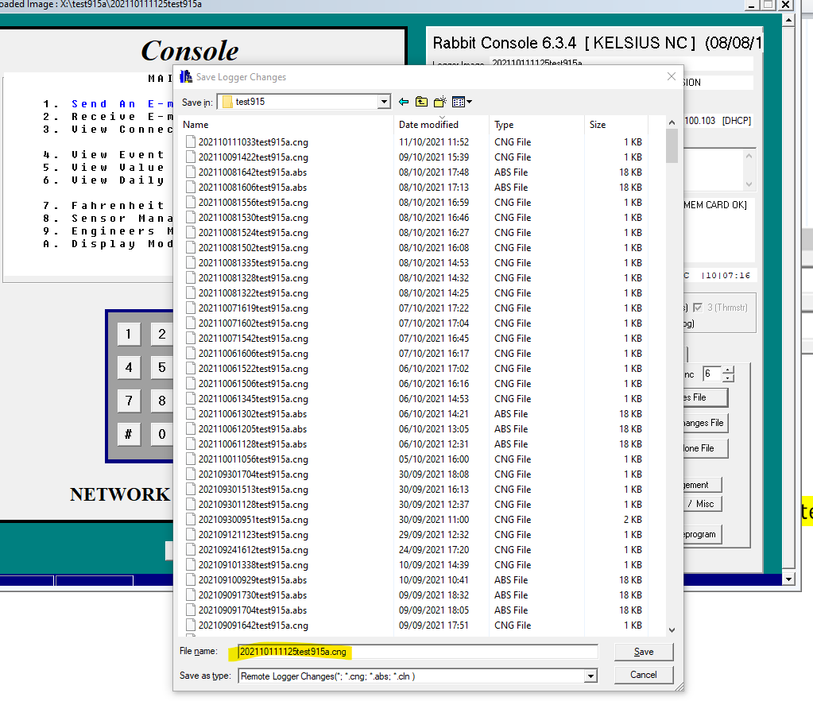

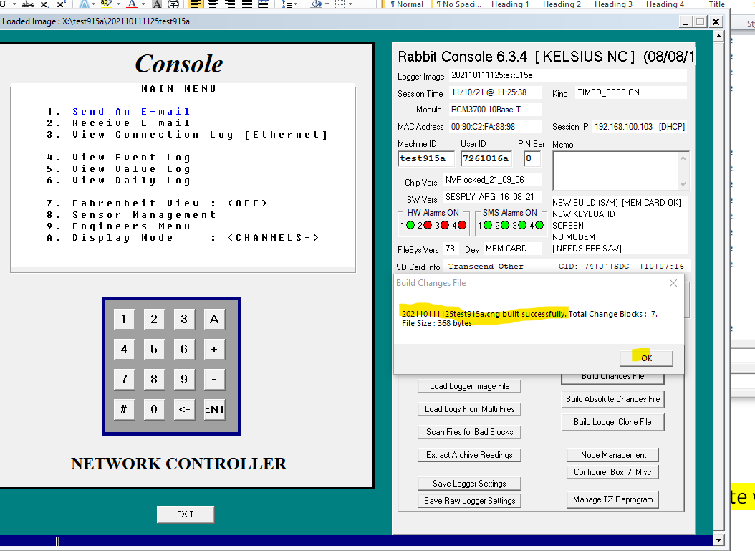

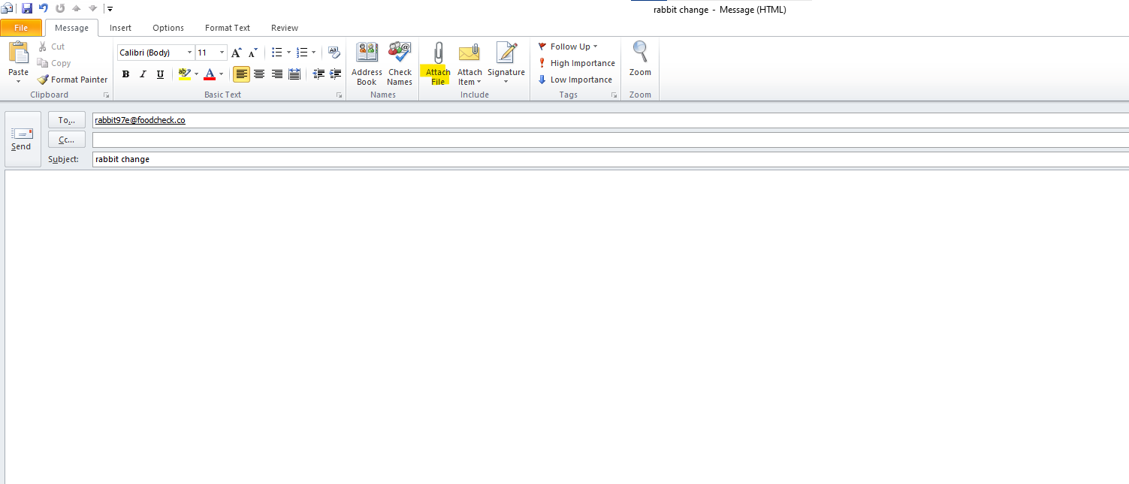

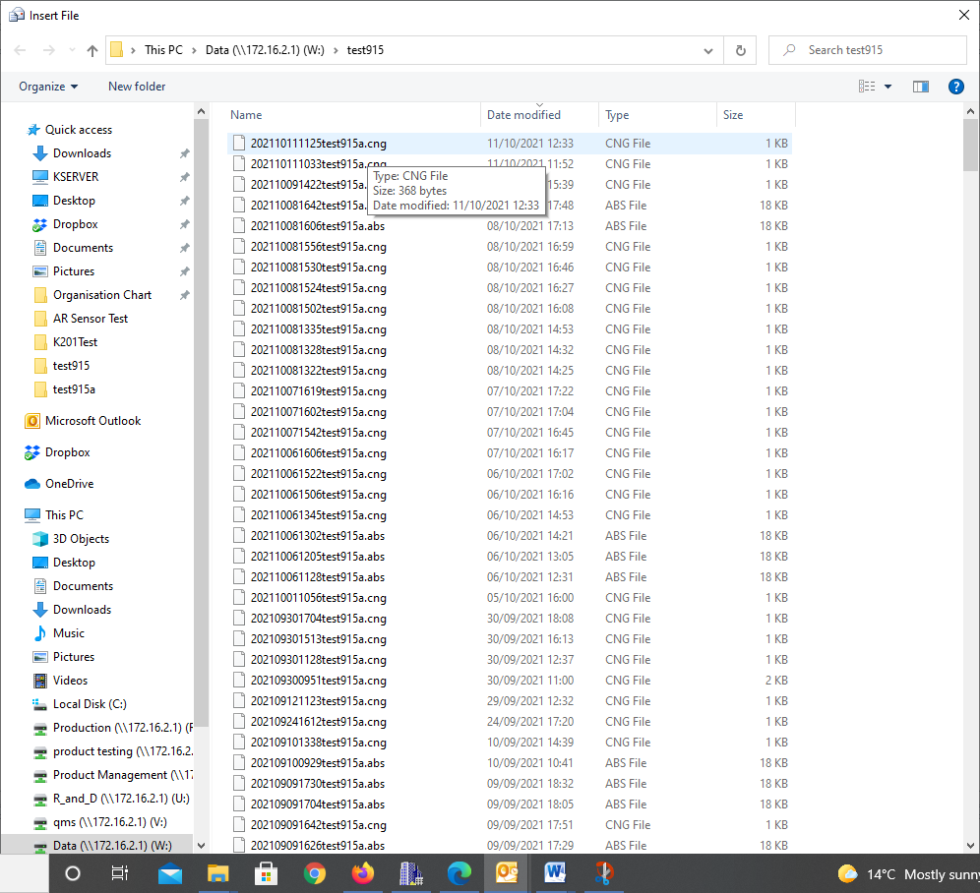

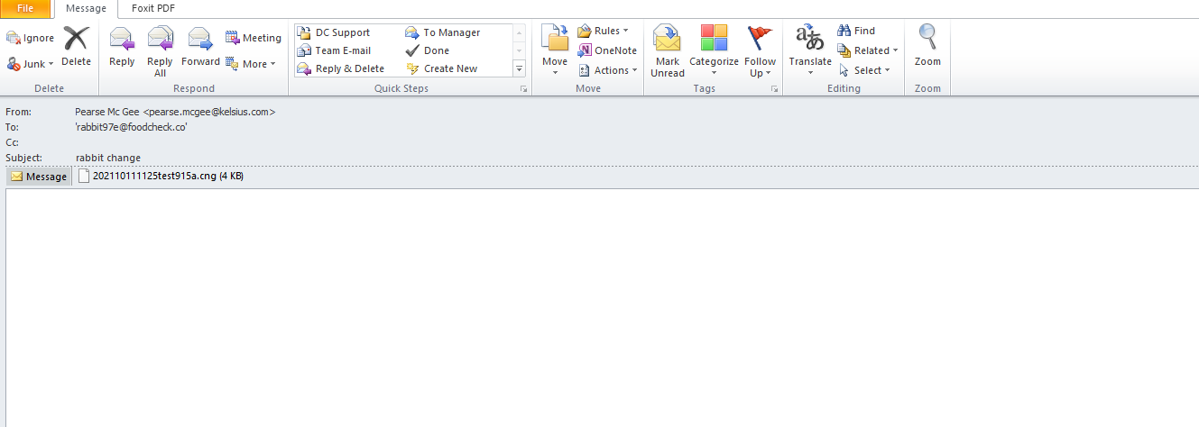

Accept Change File on NC and wait for device to communicate with RV

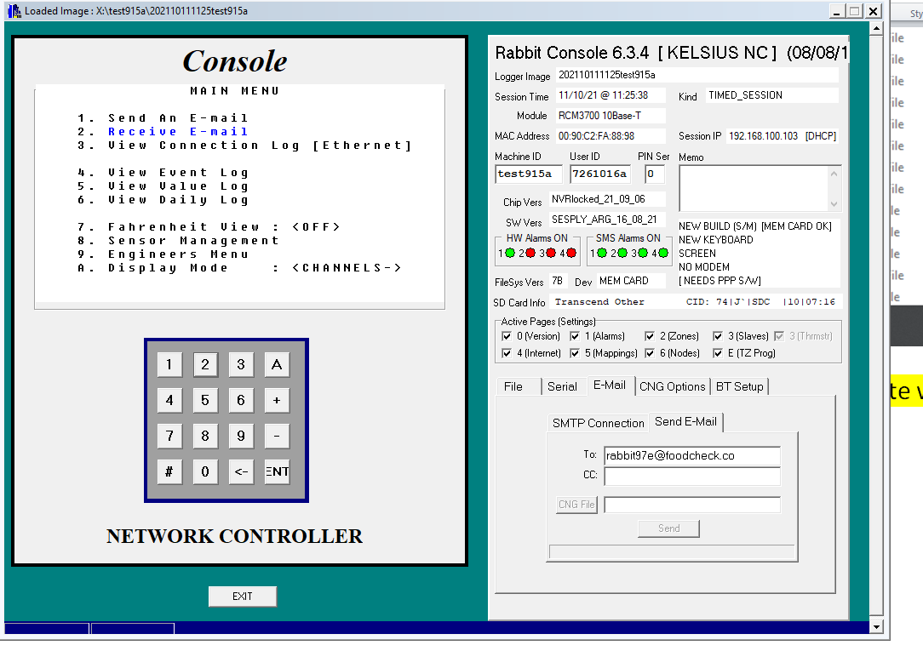

TEST CASE 1.2 SET-UP- Device will set up on the viewer correctly.

Right click channel on *Site Management* and Select *Edit Channel* from options

Verify correct set-up

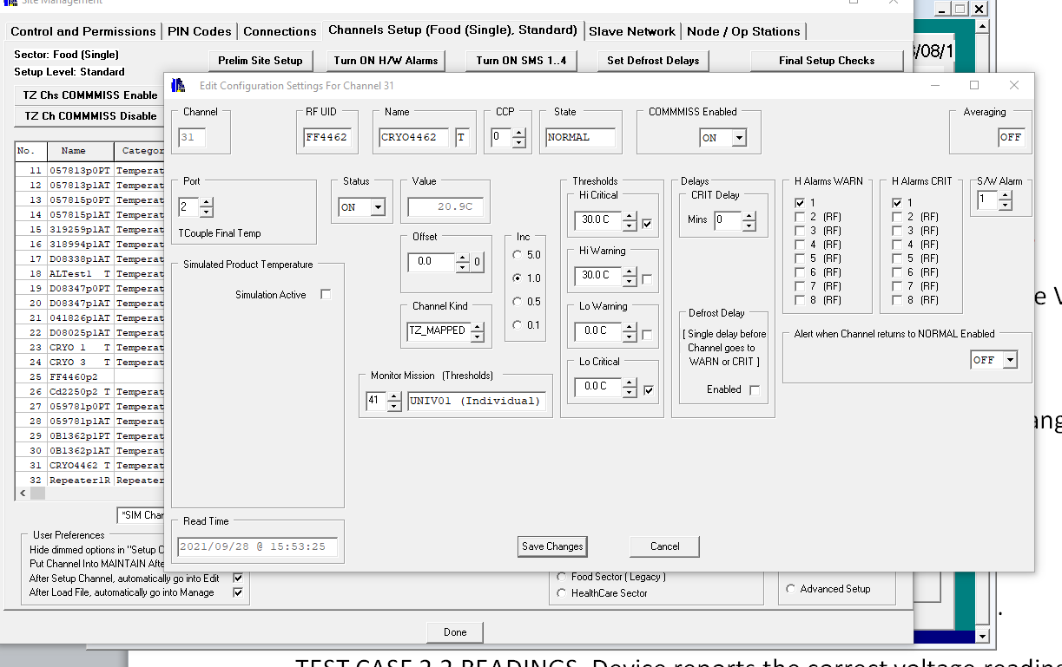

TEST CASE 1.3 SET-UP - Device settings can be reconfigured on the Viewer

While in *Edit Channel* make several changes

Threshold

Name

Delay

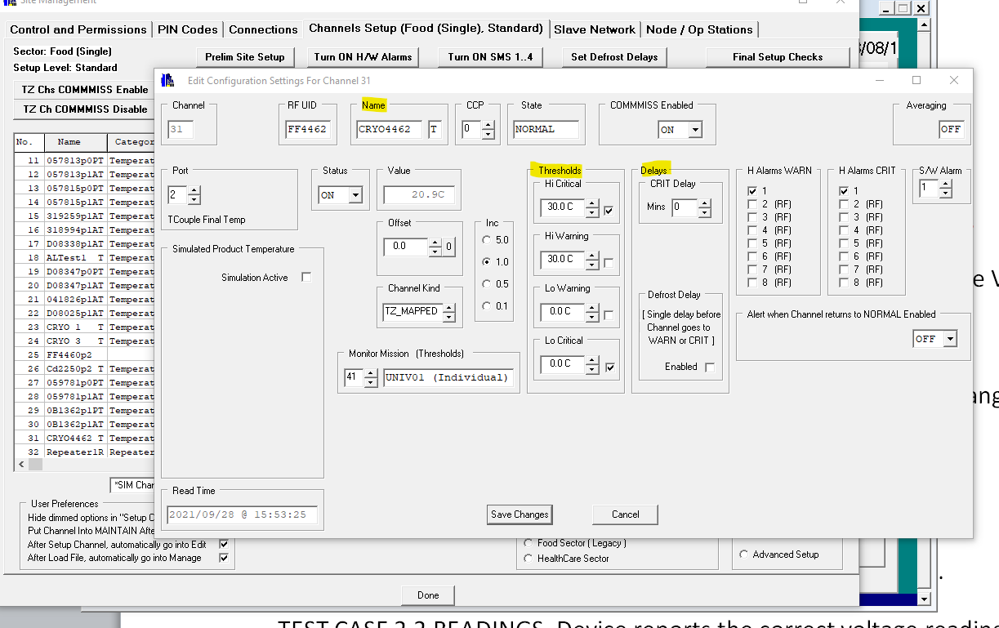

Build Change File and verify changes on subsequent Logger File

TEST CASE 2.1 READINGS- Device reports all readings correctly.

TEST CASE 2.2 READINGS- Device reports the correct voltage reading.

Verify voltage readings on *RV / Slave Network*

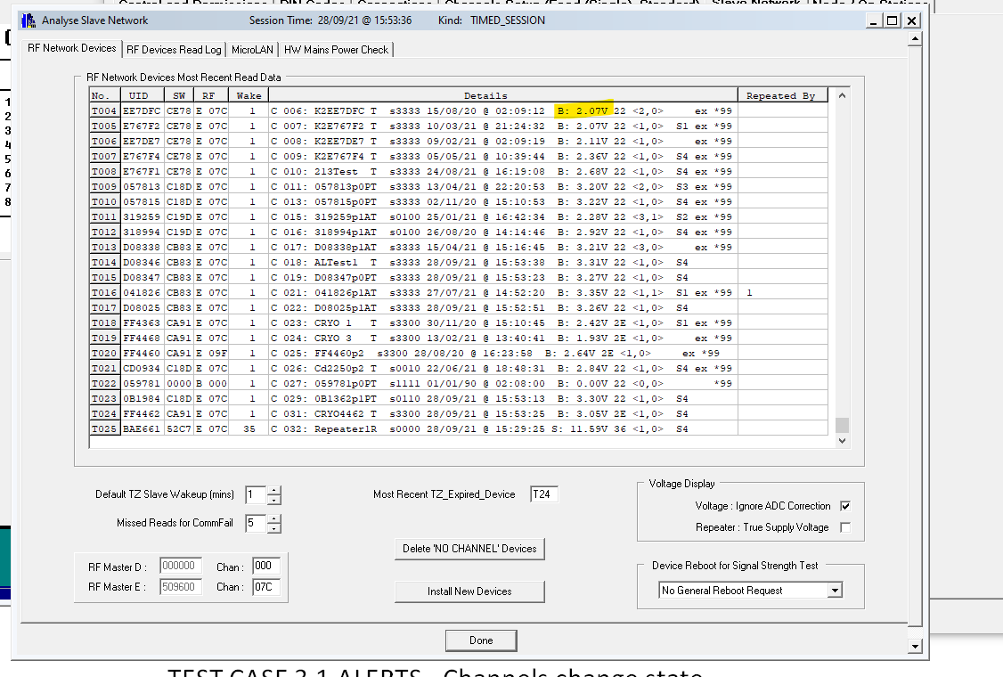

TEST CASE 2.3 READINGS- Device checks in at expected intervals.

Verify expected interval on RV / Slave Network

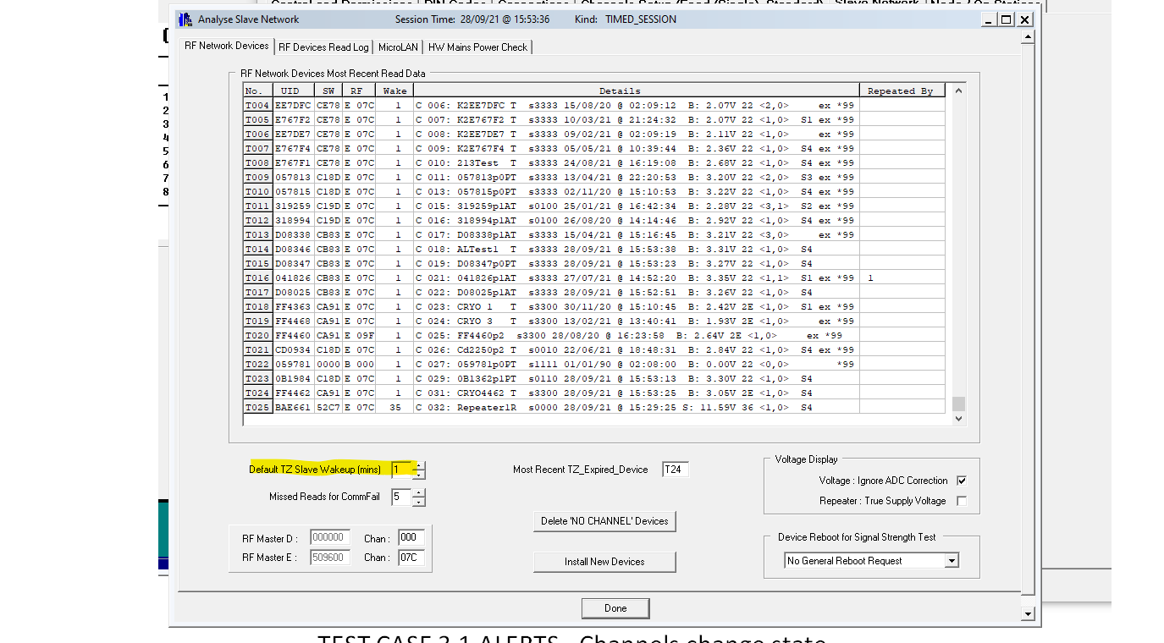

Verify check in times on RF Devices Read Log

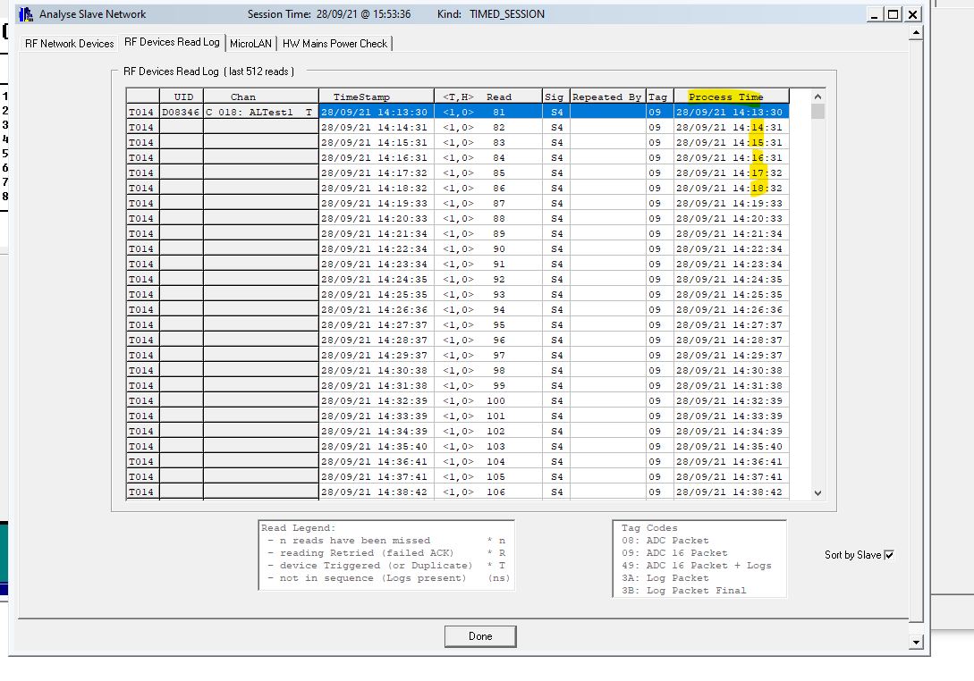

TEST CASE 2.4 READINGS- Device reboots as intended at midnight.

Verify midnight reboot on *RF Devices Read Log*

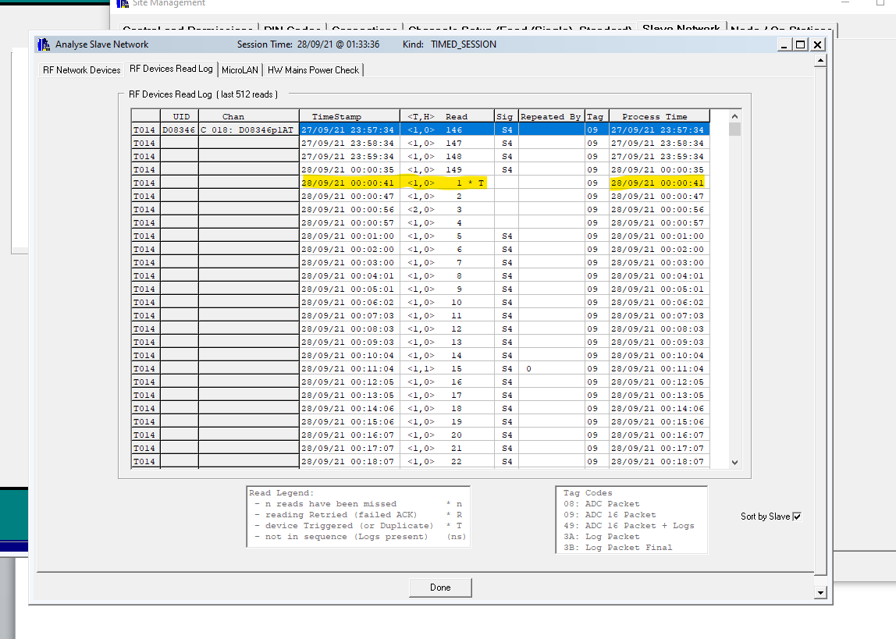

TEST CASE 2.5 READINGS- Are all signal strengths being reported correctly?

Verify signal strength readings on *RF Devices Read Log*

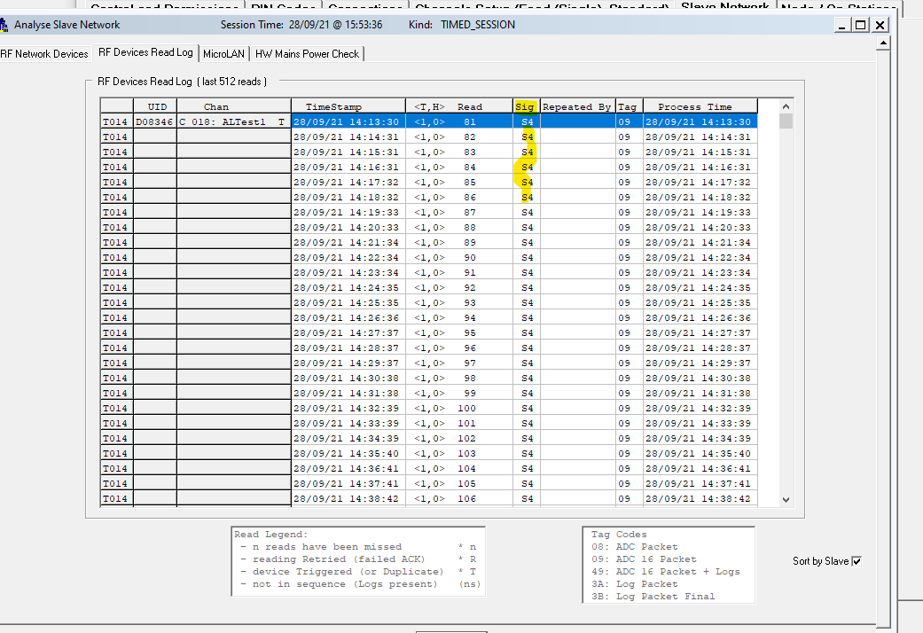

TEST CASE 3.1 ALERTS - Channels change state

3.1.1 When intended thresholds are exceeded

Change a threshold on RV

Verify channel enters an Alert state

BEFORE

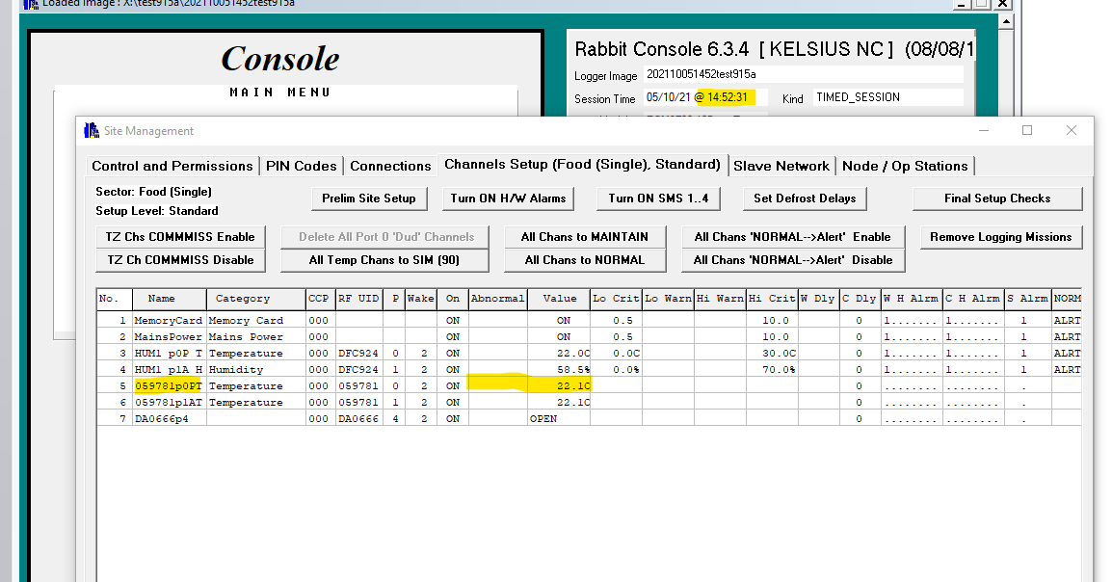

DURING

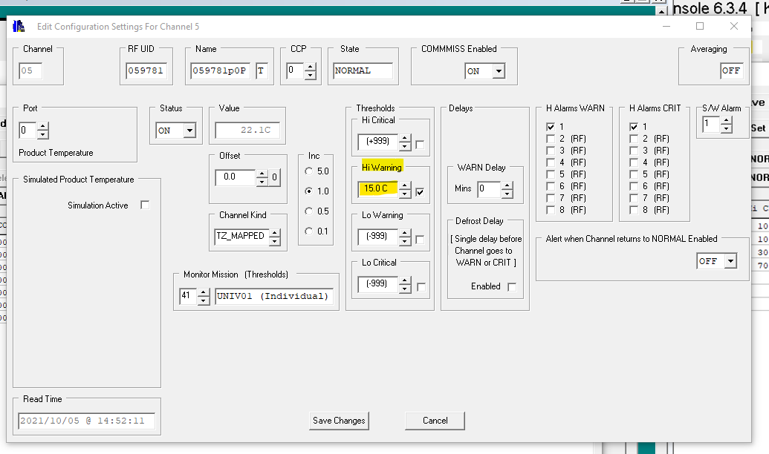

AFTER

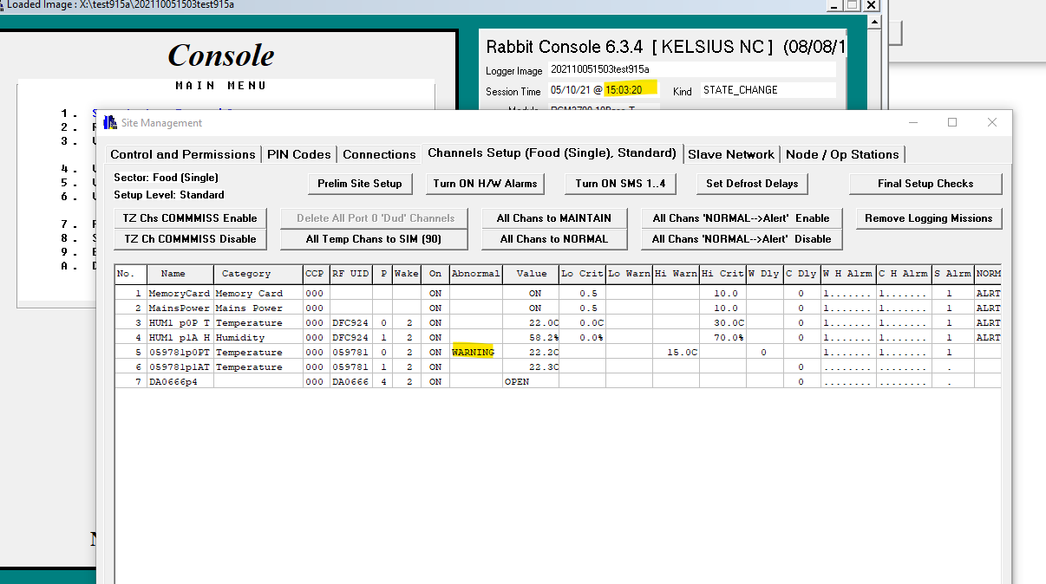

3.1.2 After specified delays.

Change a threshold on RV

Change a delay time

Verify channel enters an Alert state after delay

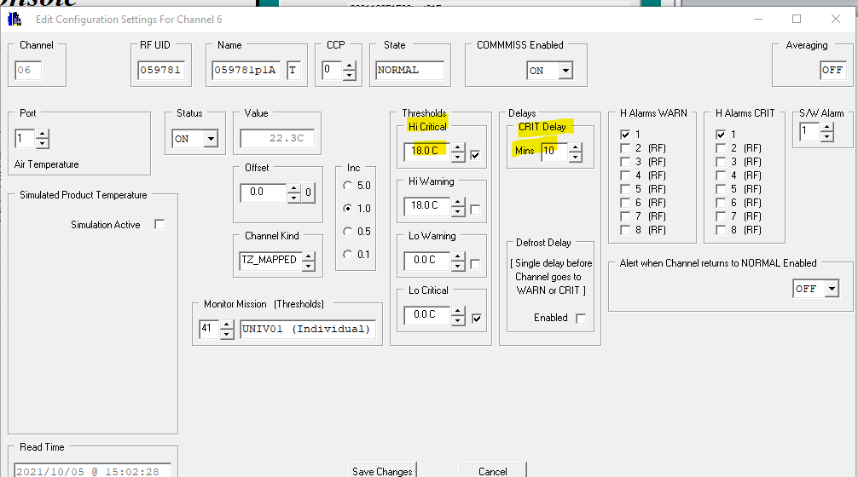

TEST CASE 3.2 ALERTS - Expired alerts work correctly.

Set up Contact Groups in Portal

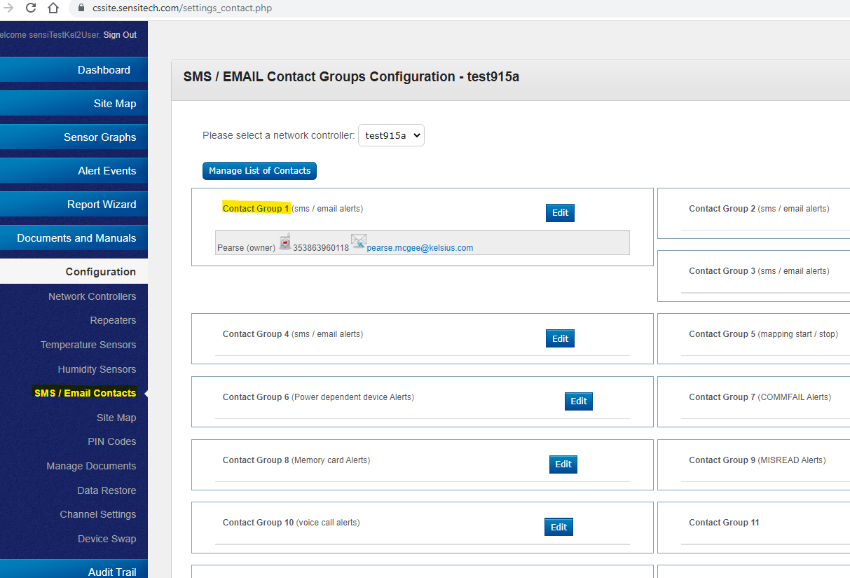

Edit channels on RV.

Change Monitor Mission to 41 and assign this Contact Group number to S/W alarm

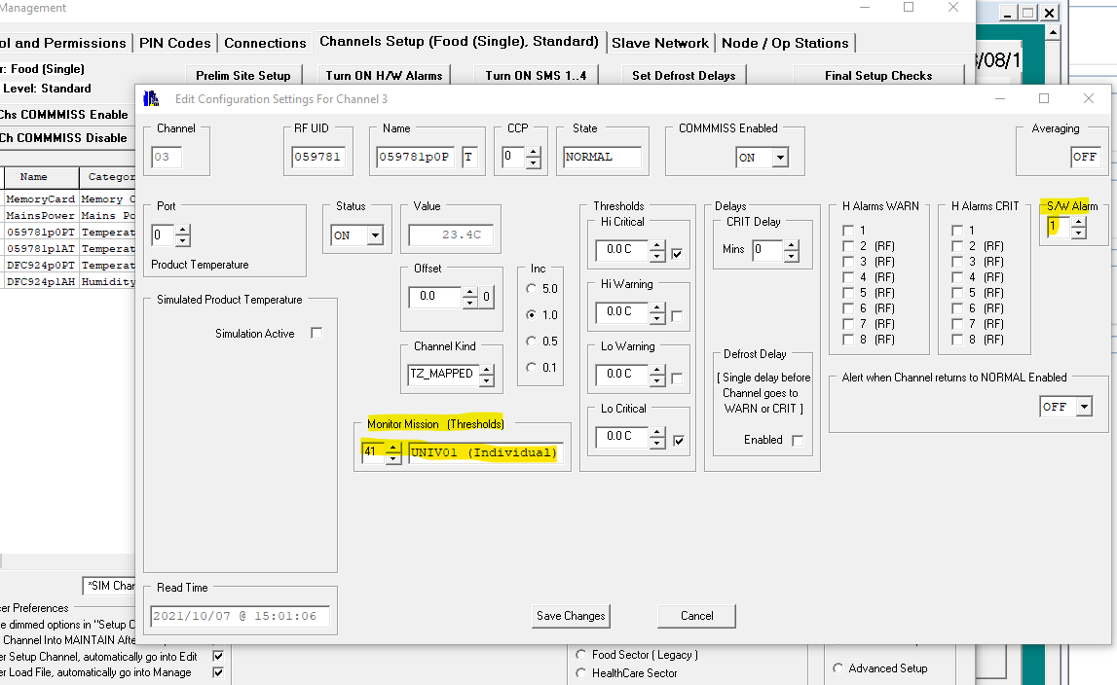

Trigger Alert state on RV (as above)

Verify alerts are received on SMS/Email

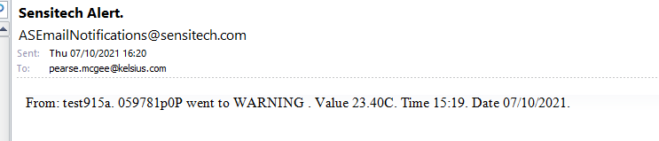

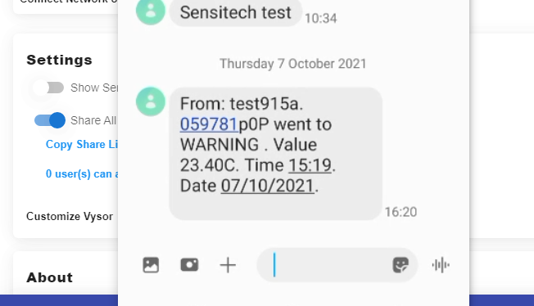

TEST CASE 3.3 ALERTS - Historic alerts for Logging sensors work correctly.

TEST CASE 3.4 ALERTS - Logging sensors work correctly.

Place Sensor in fridge/freezer in Normal state.

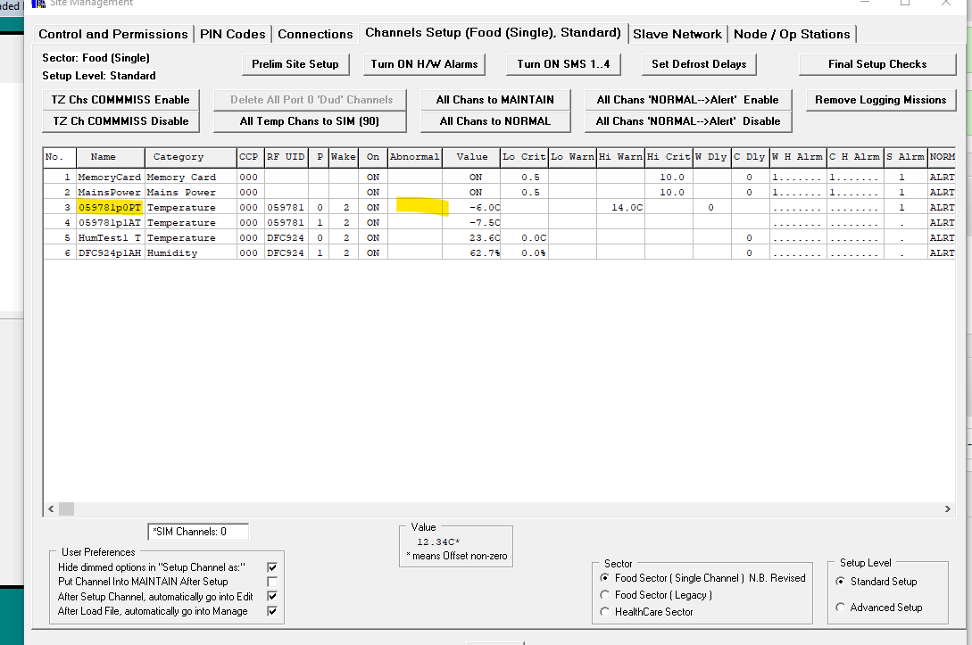

Remove Sensor outside NC range, generating a Commfail state.

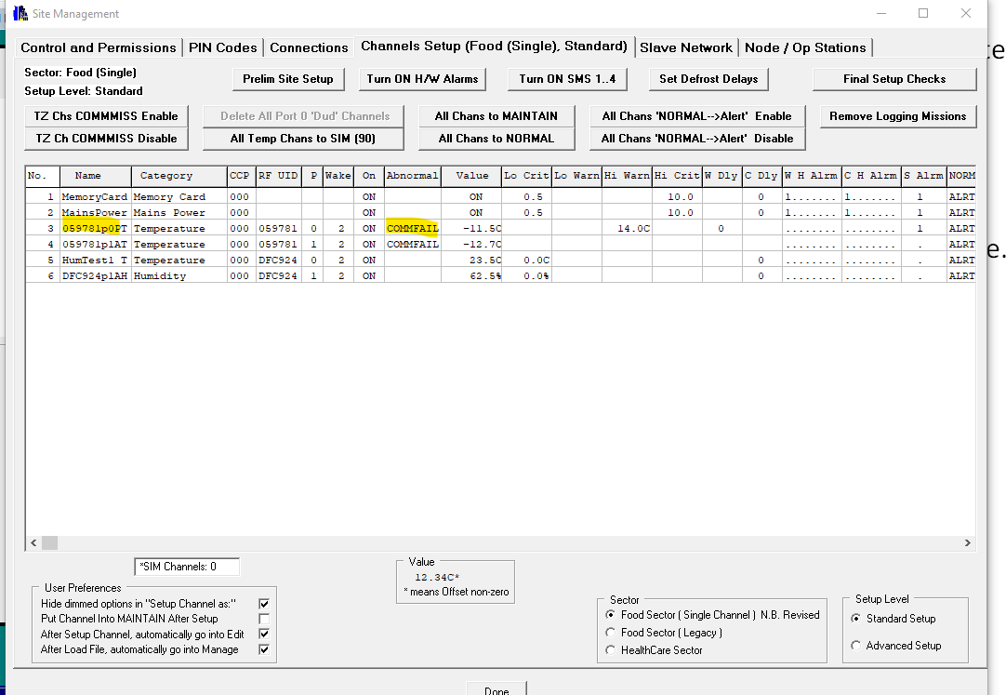

Allow Sensor to return to a Warning state.

Allow Sensor to remain out of range of NC for a period of time.

Return Sensor to within range of NC.

Verify you receive a Historical alert.

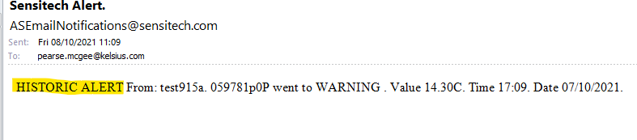

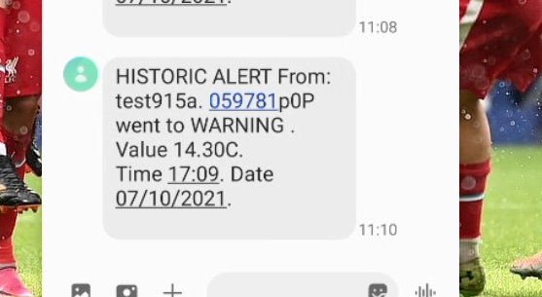

Verify the Sensor logs are restored.

LOGS ON RECONNECTING

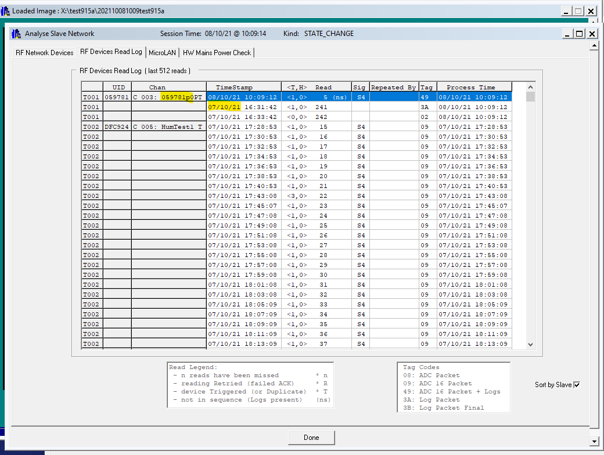

LOGS FULLY RESTORED

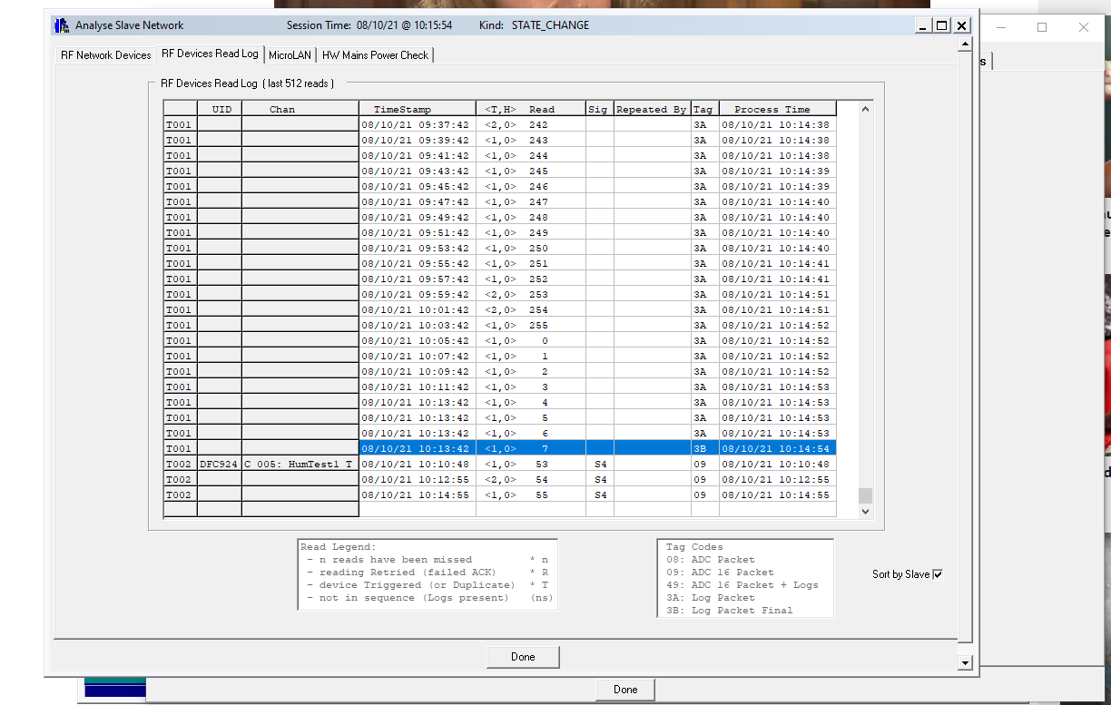

TEST CASE 4.1 PORTAL - Results appear on the web correctly in the following sections

4.1.1 Dashboard

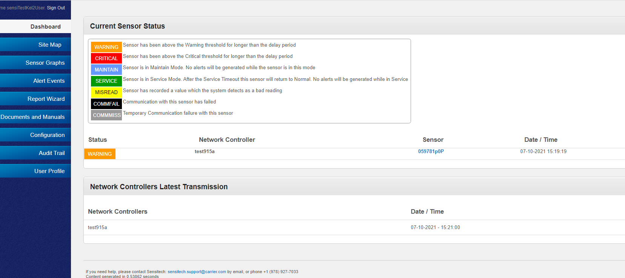

4.1.2 Site Map

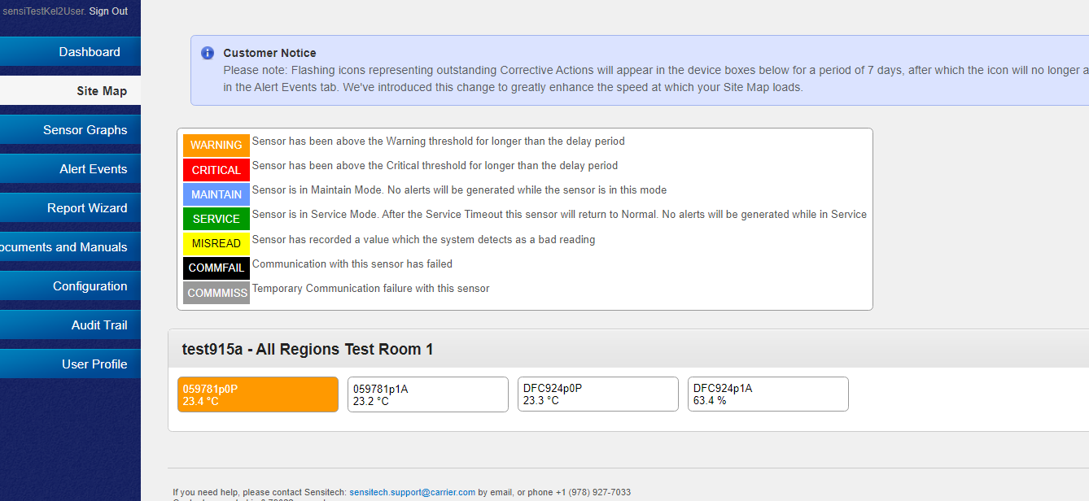

4.1.3 Sensor Graph

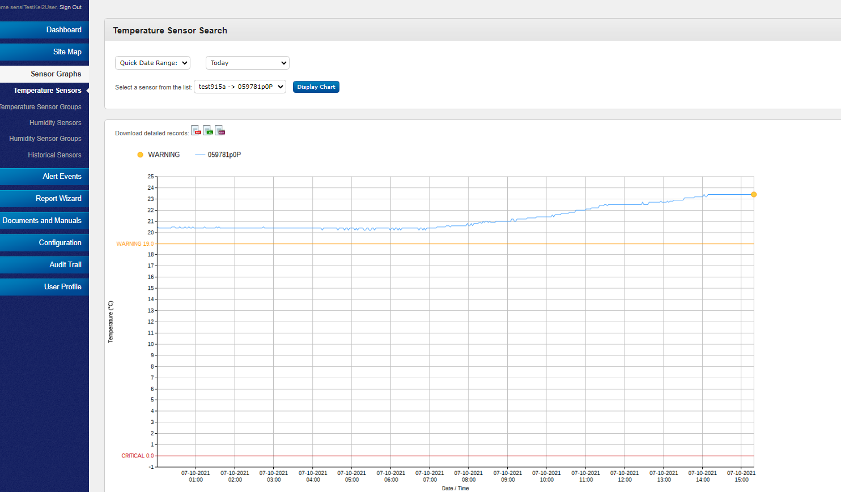

4.1.4 Alert Events

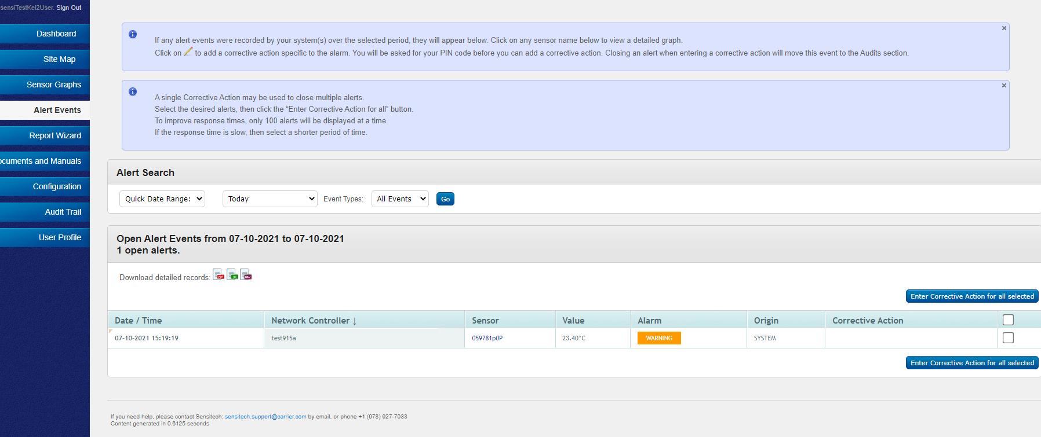

4.1.5 Report Wizard

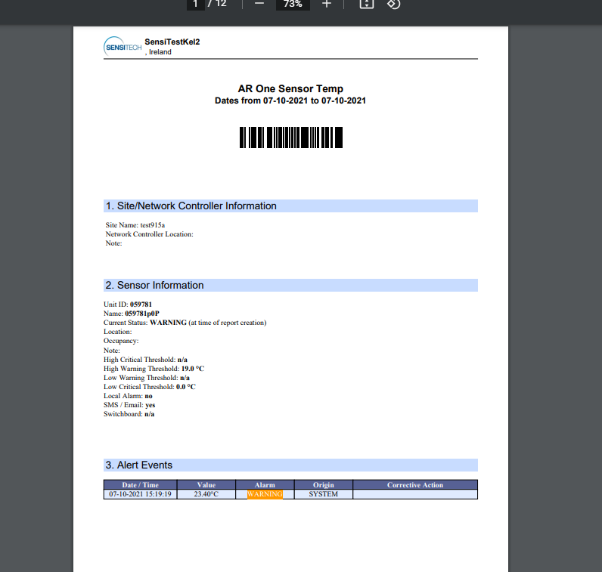

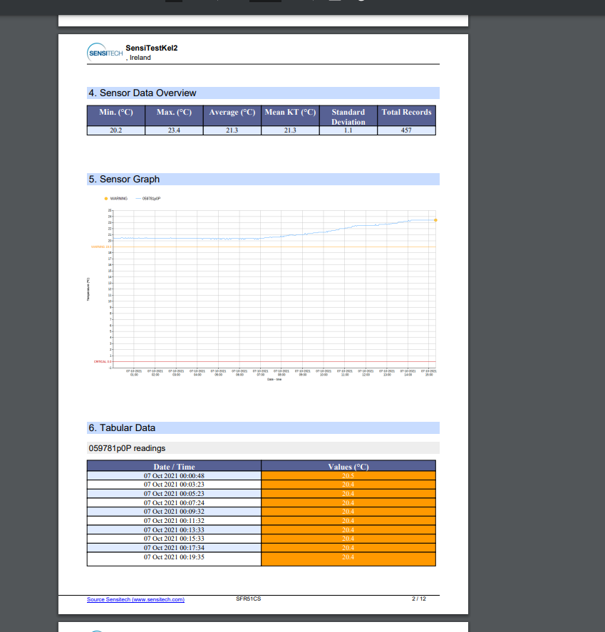

4.1.6 Audit Trail

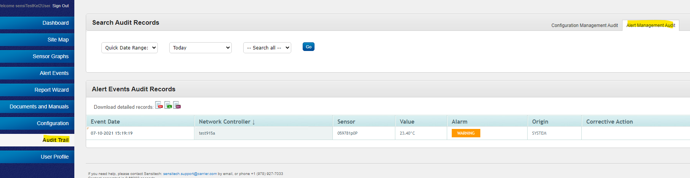

TEST CASE 4.2 PORTAL - Device settings can be reconfigured on the Portal

BEFORE : RV

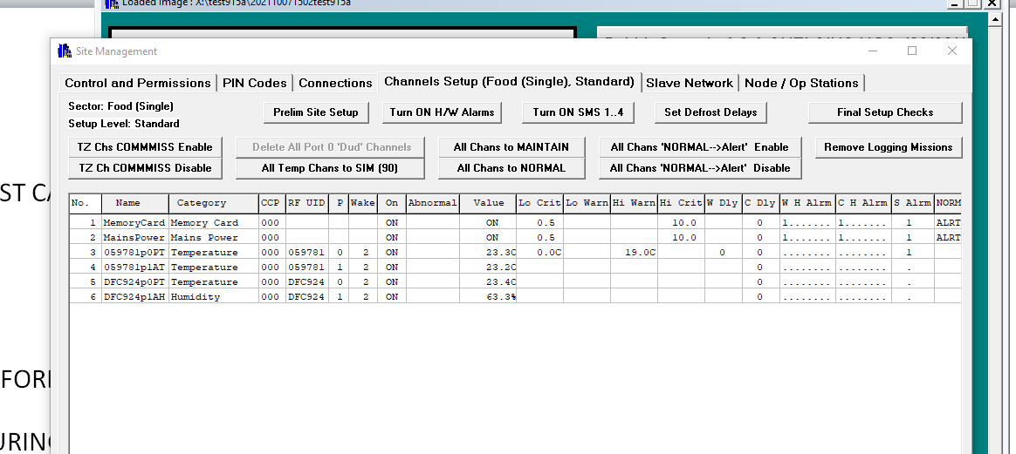

BEFORE : PORTAL CHANNEL SETTINGS

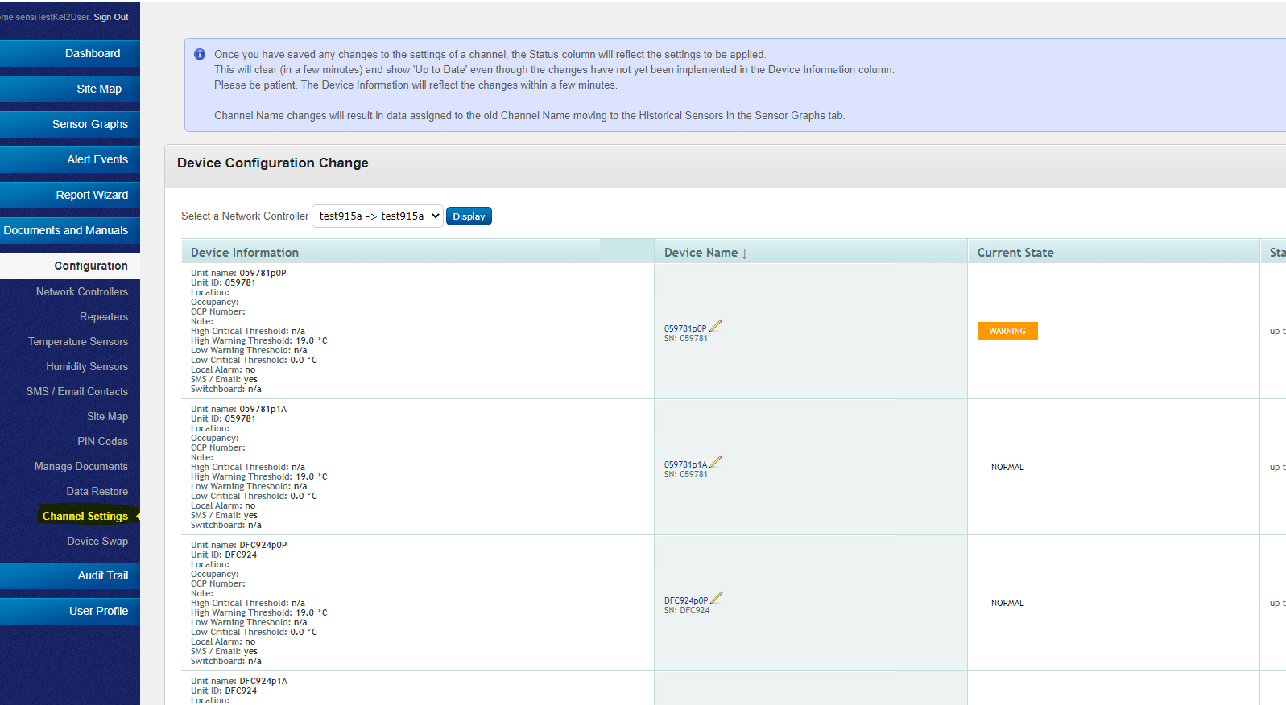

DURING

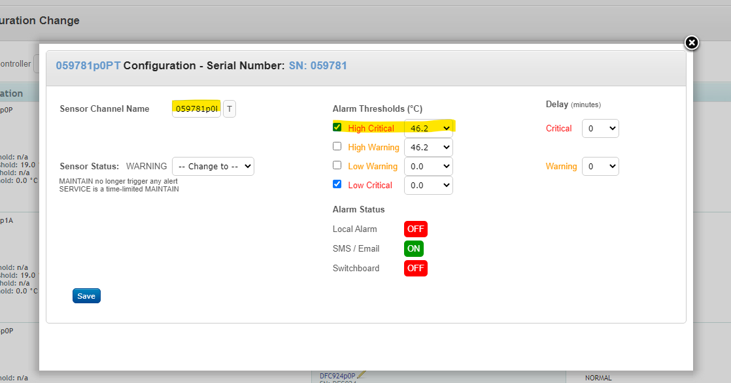

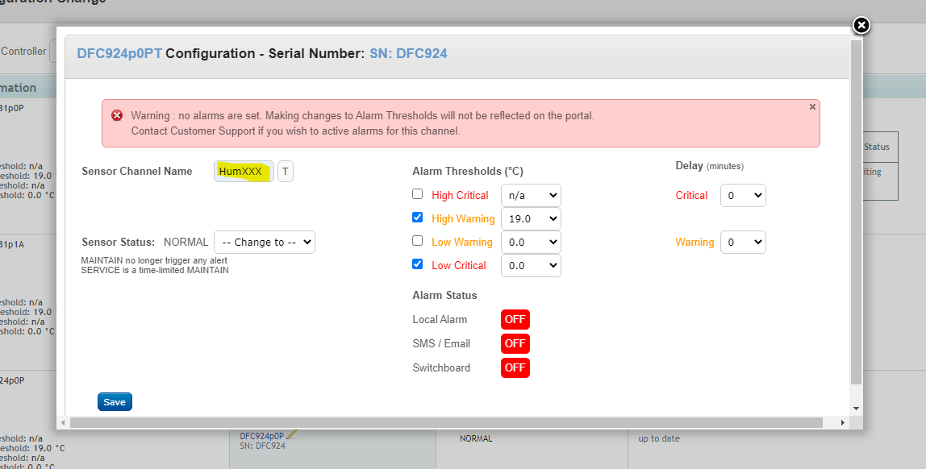

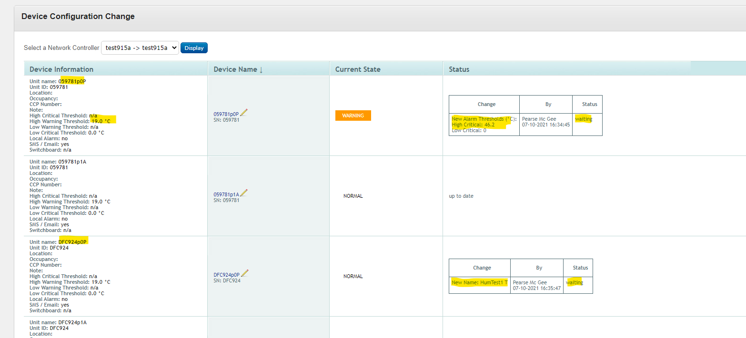

AFTER RV

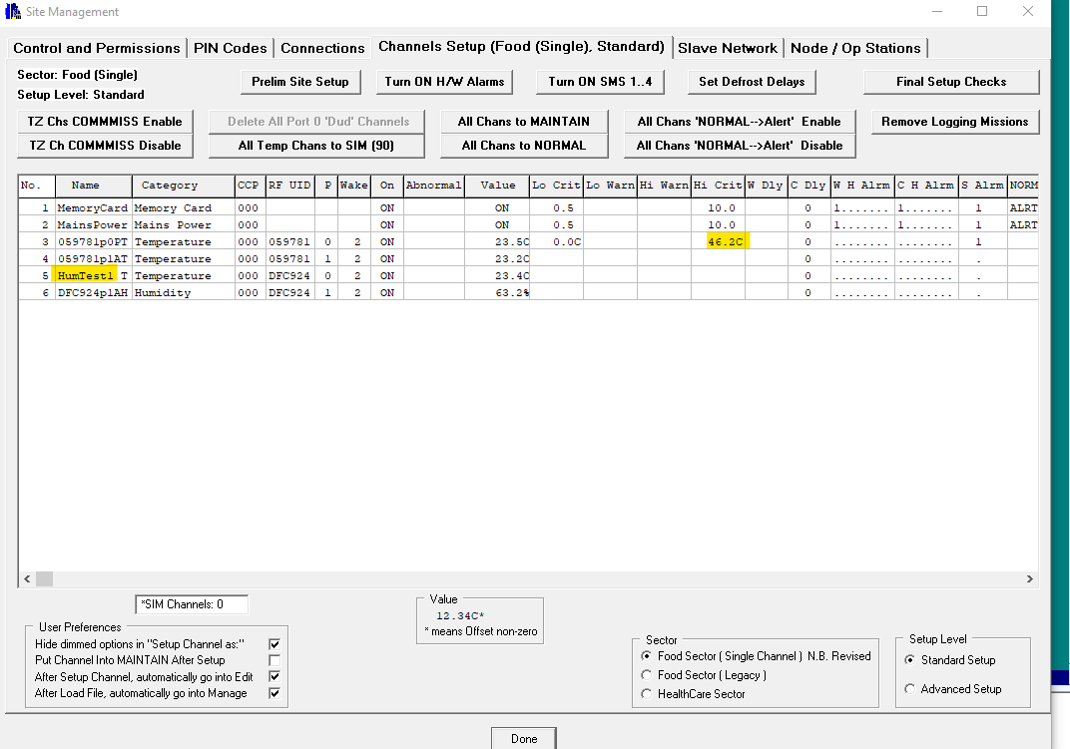

AFTER PORTAL CHANNEL SETTINGS

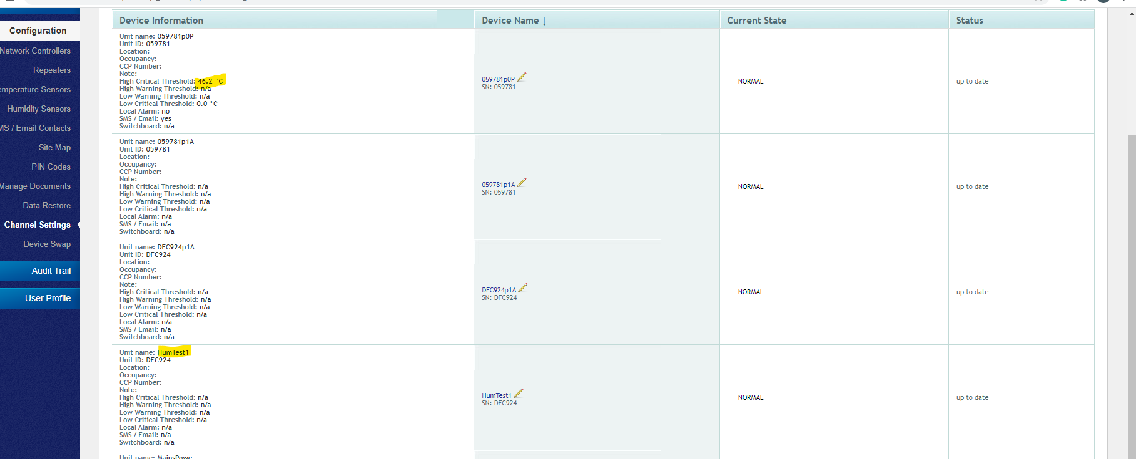

TEST CASE 4.3 PORTAL - Devices can be swapped via the Portal

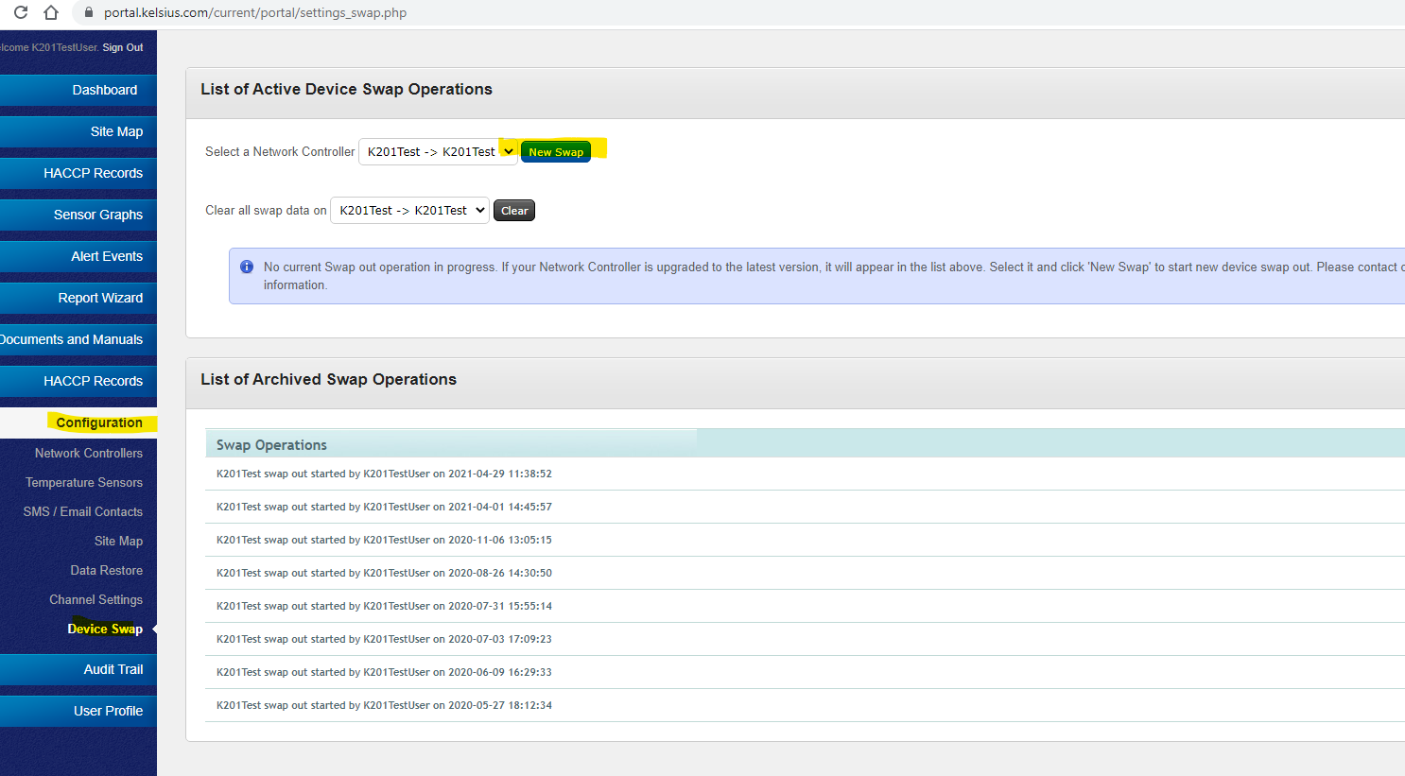

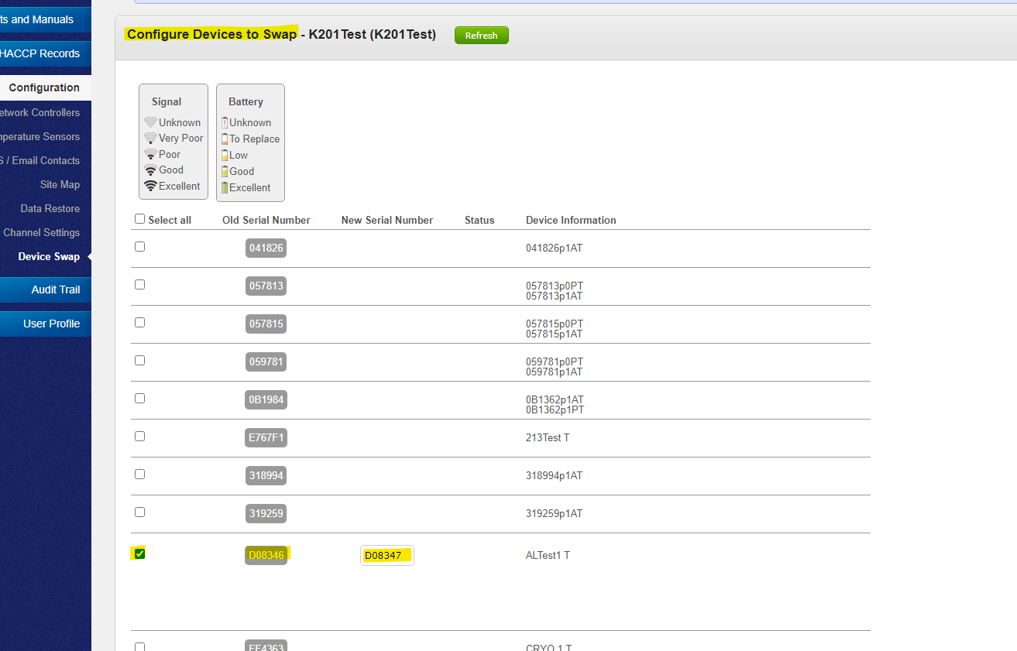

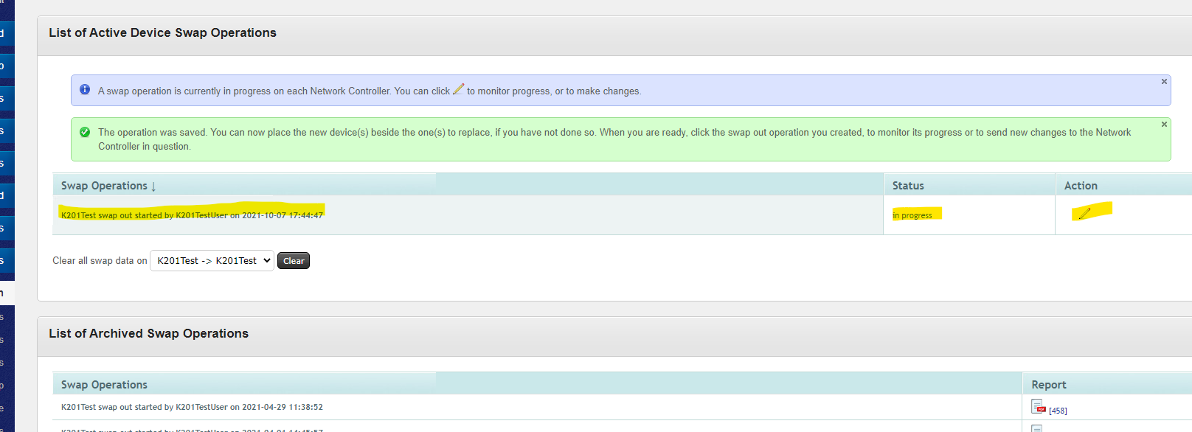

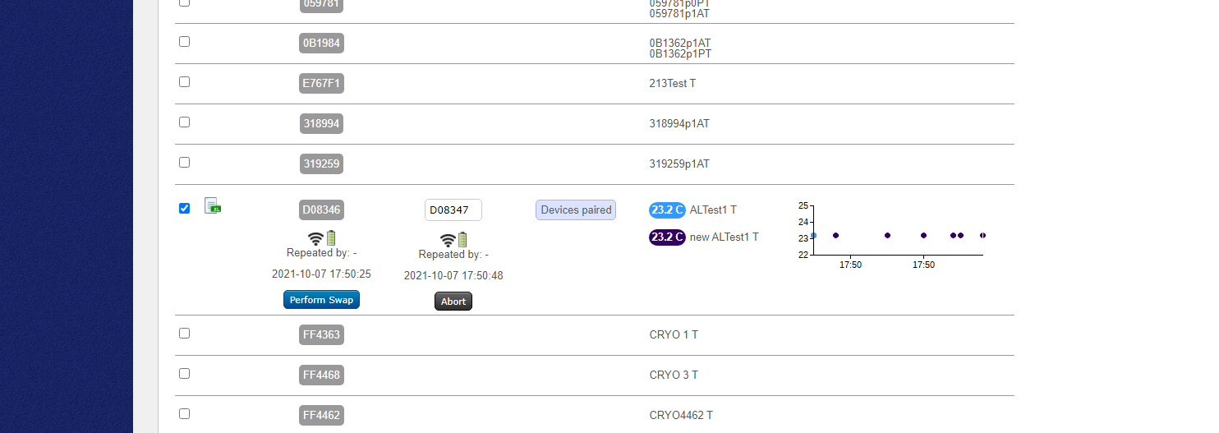

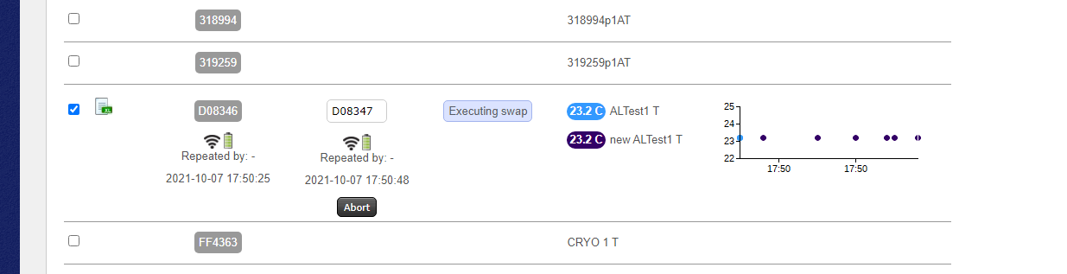

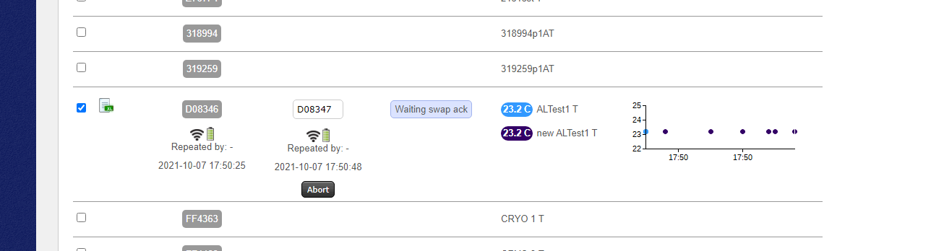

SWAP DONE

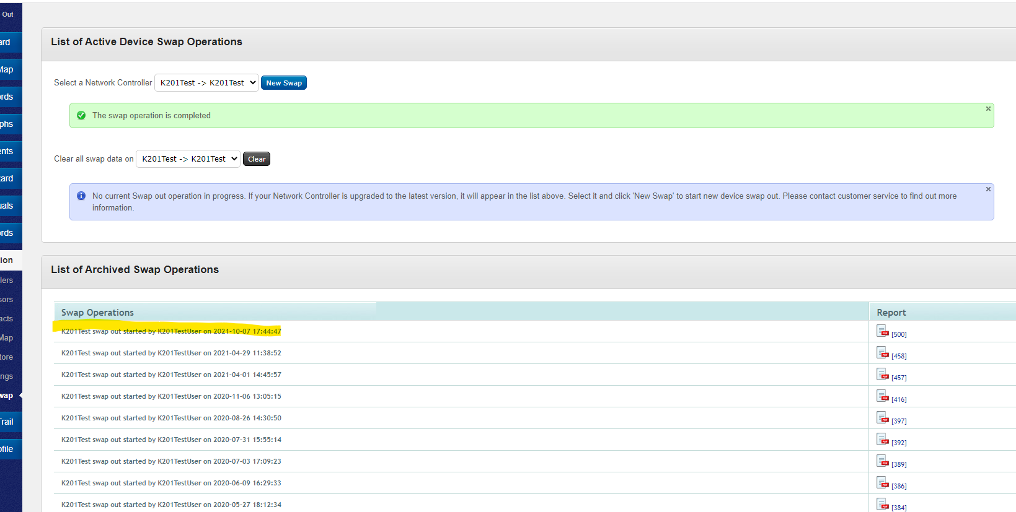

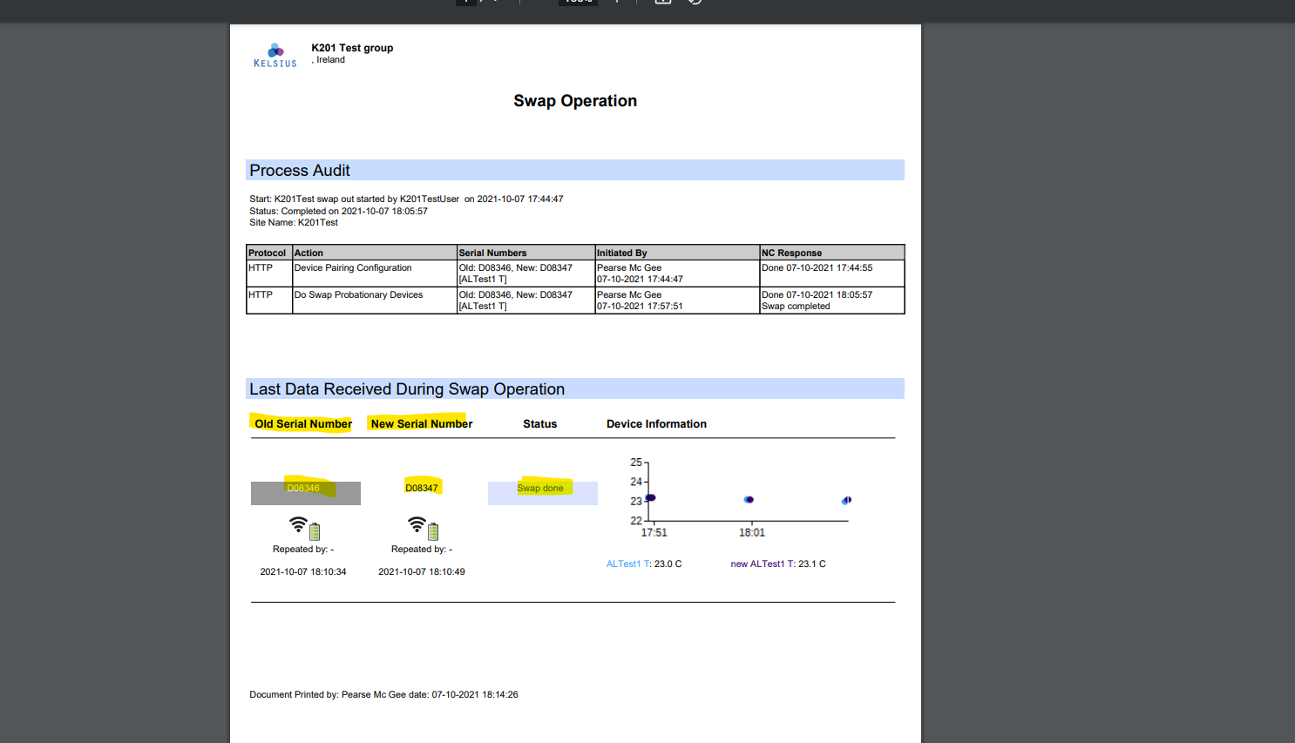

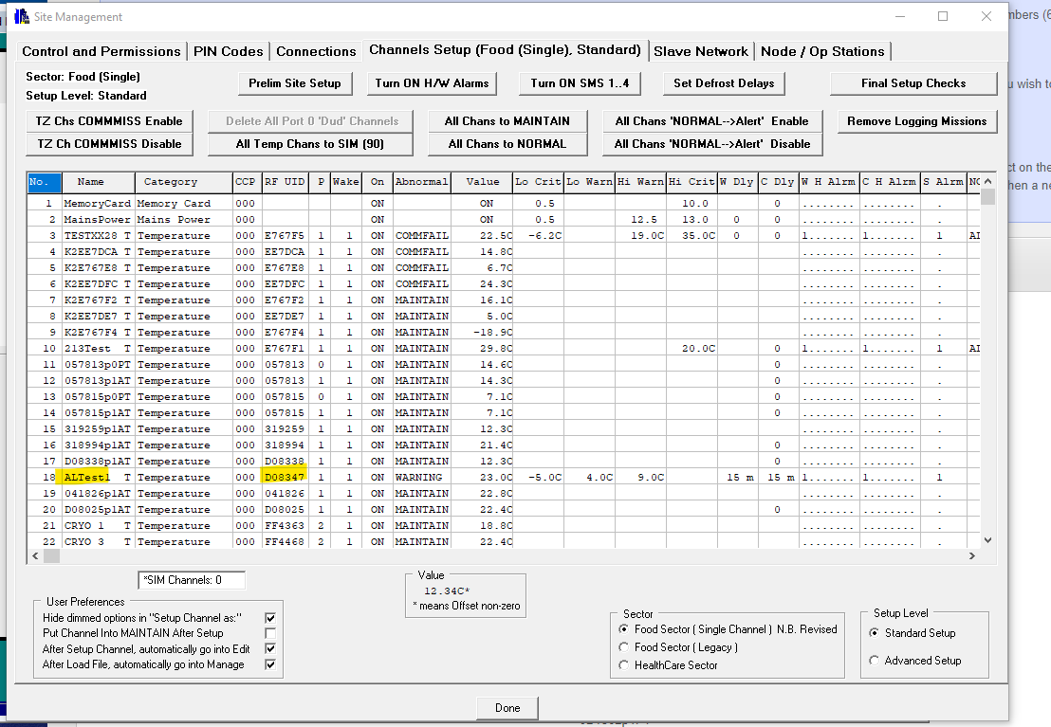

TEST CASE 5.1 FINAL CHECKS- Device is reprogrammable with new SW – RV

Click on *Manage TZ Reprogram* button

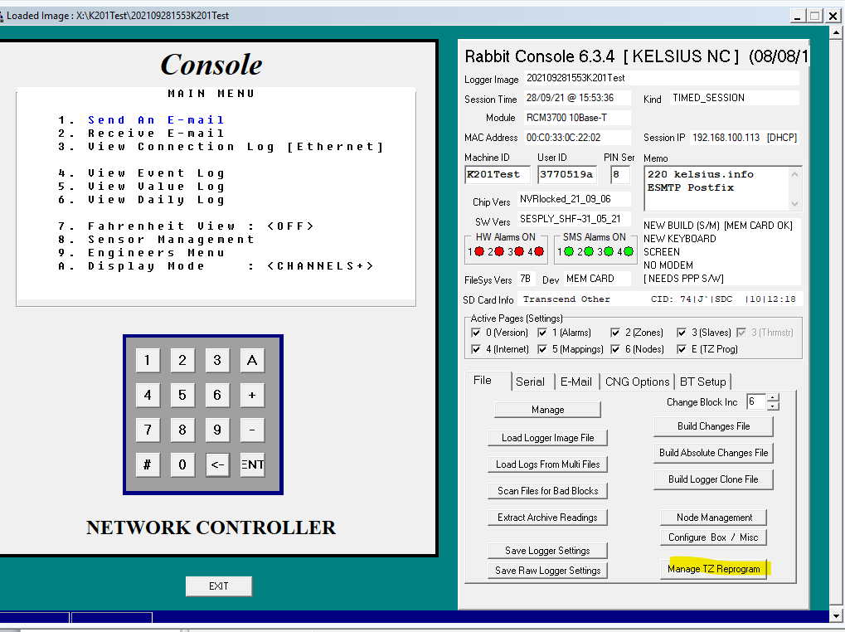

Click on *Define New Reprogramming Spec*

*Load* new software binary file

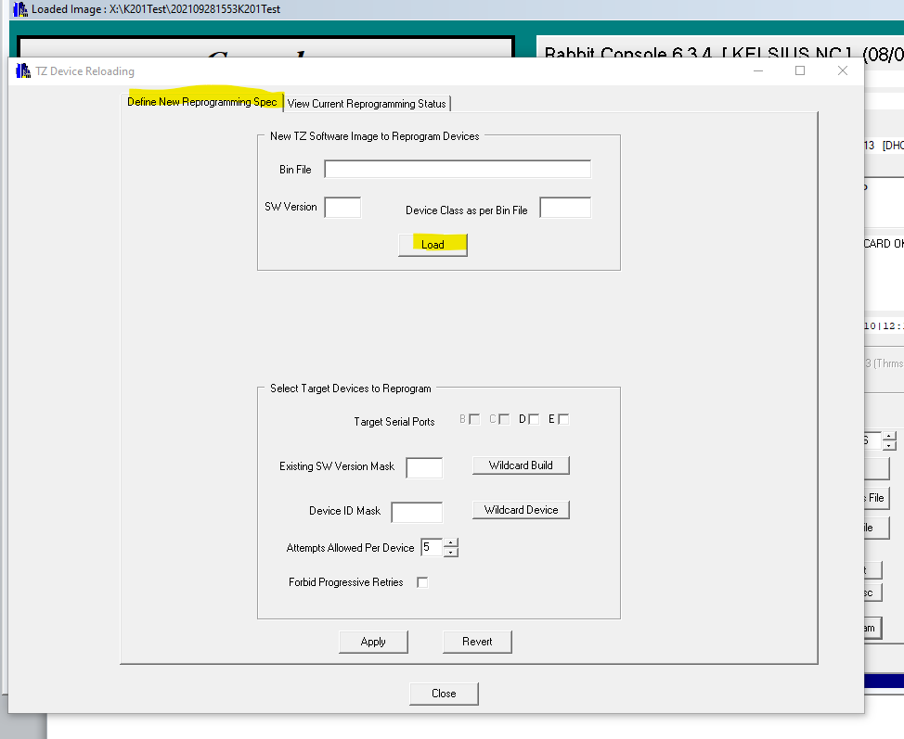

Adjust the following in the *Select Target Devices To Reprogram* section

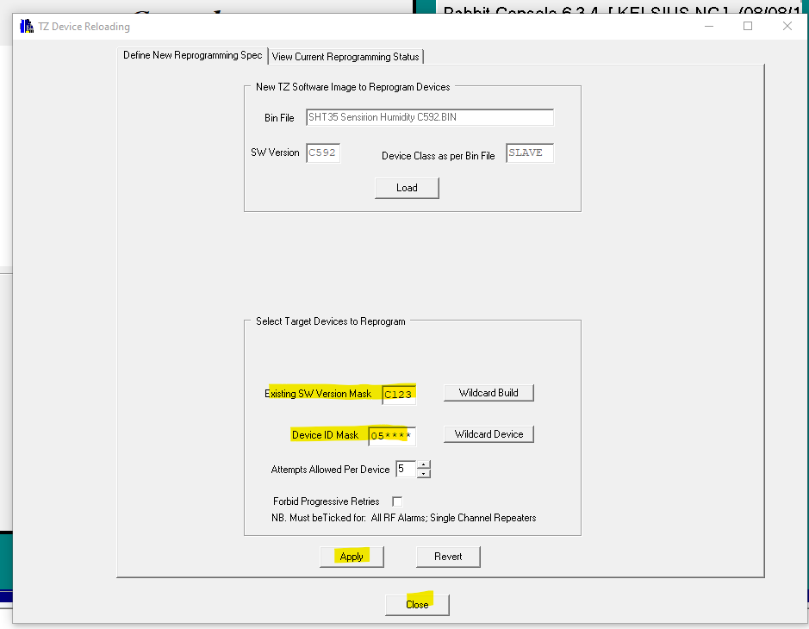

Click *Apply* button

Click *Close* button

Untick all the *Active* pages except ***E(TZ Prog)***

Click *Build Absolute Change File*

Save and send to RV

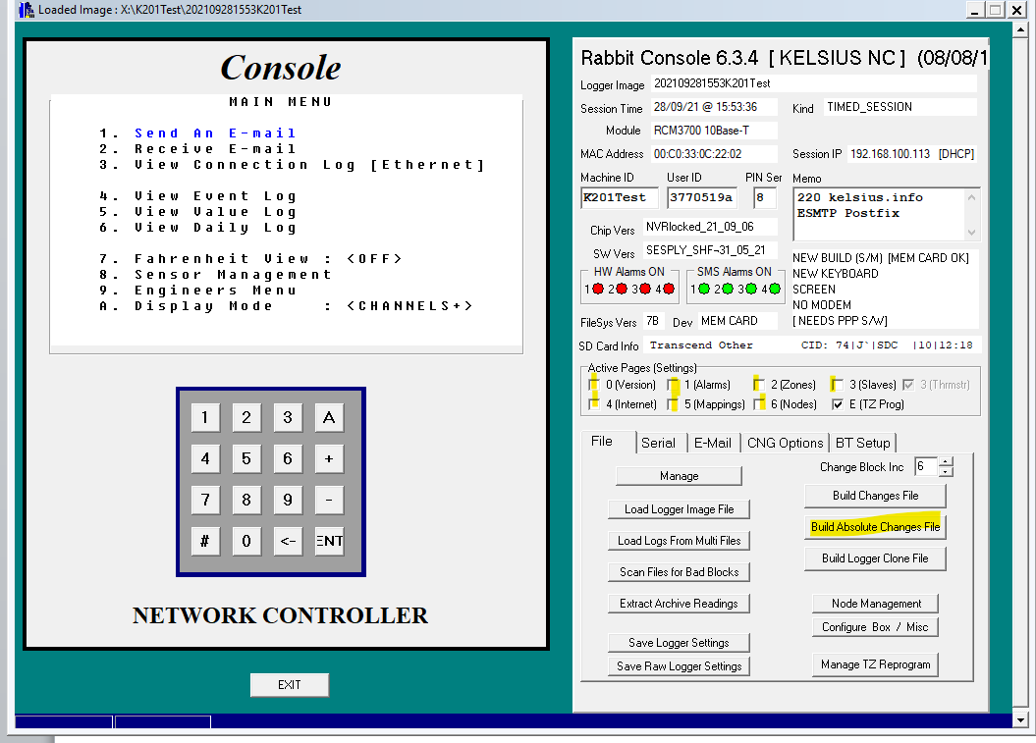

Monitor the Software change in subsequent files via

*Manage TZ Reprogam* button

*View Current Reprogramming Status* tab

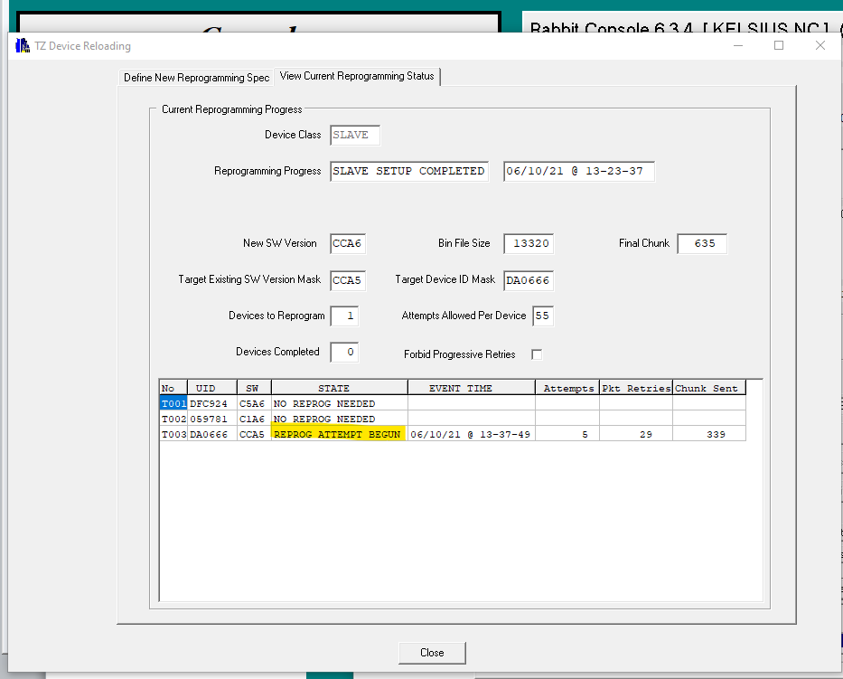

Once Device has been reprogrammed verify software in *Slave Network*

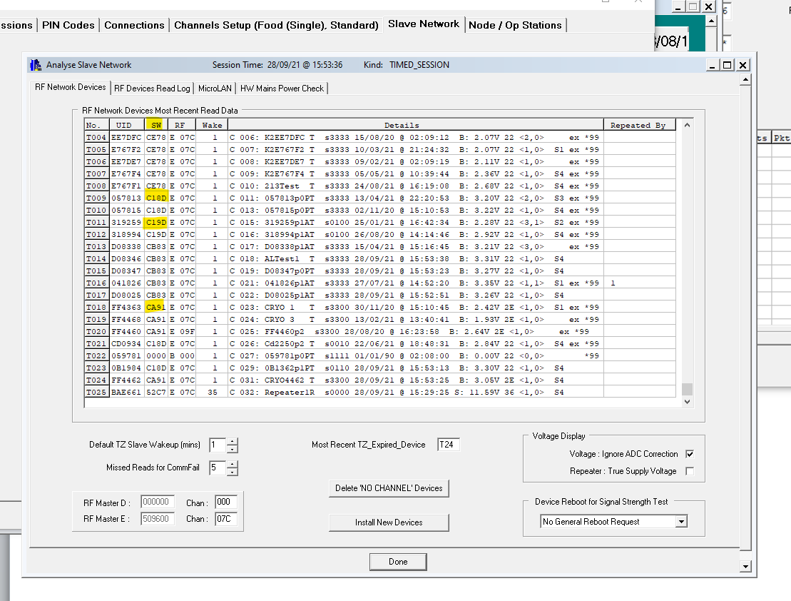

TEST CASE 5.2 FINAL CHECKS- Device uninstalls correctly – RV

On Site Management screen right click on the channel of the device to be deleted

Select *Delete Channel* from options

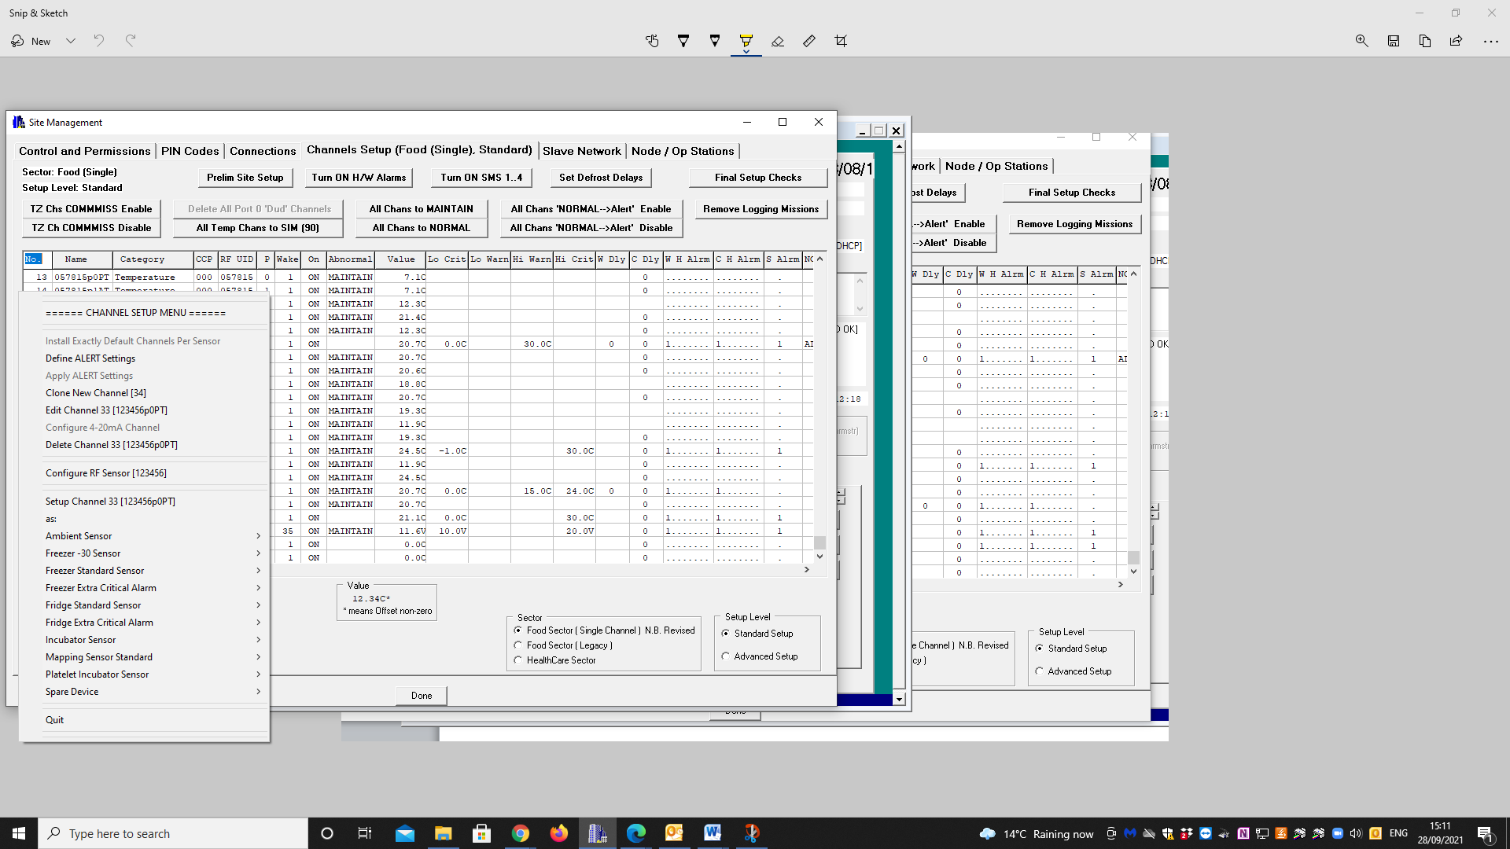

Ensure *Channel Delete* pop-up box appears and click *OK*

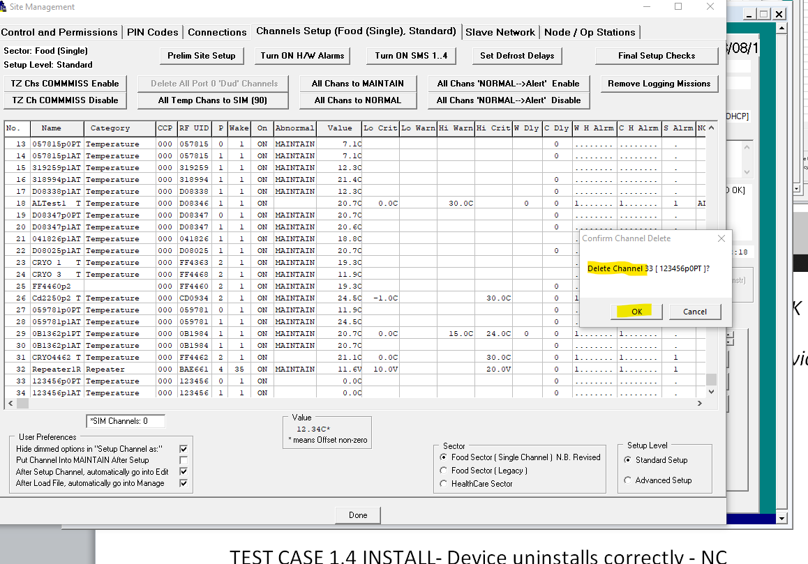

In Slave Network screen click *Delete ‘NO CHANNEL’ Devices* box

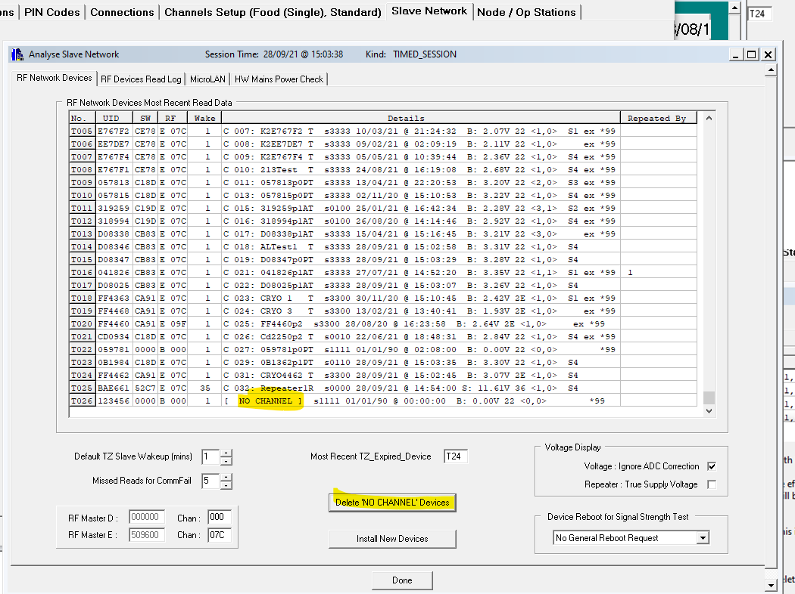

Verify *Information* pop-up box and click *OK*

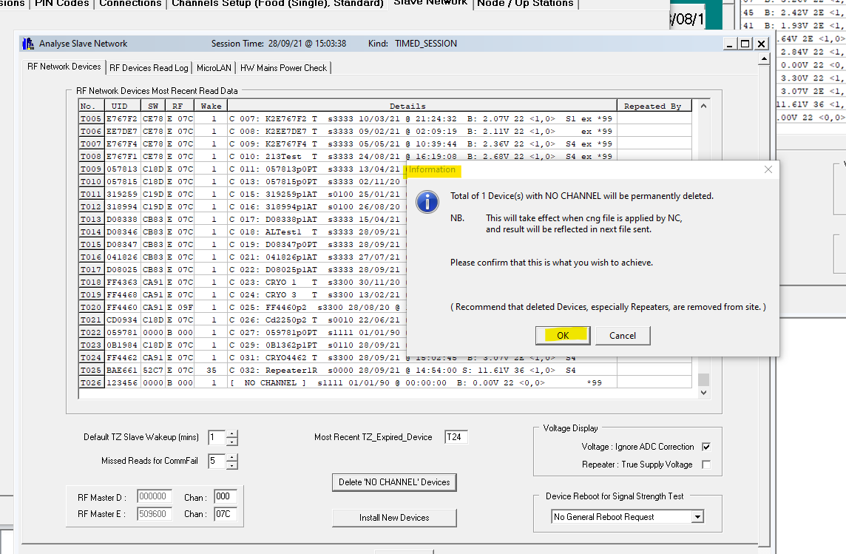

Click DONE button in Slave Network screen and DONE button in Site Management

Build and send Change file

Verify channels are deleted in subsequent Image Logger file

TEST CASE 5.3 FINAL CHECKS - Device installs correctly – NC

BEFORE- NC Chans screen

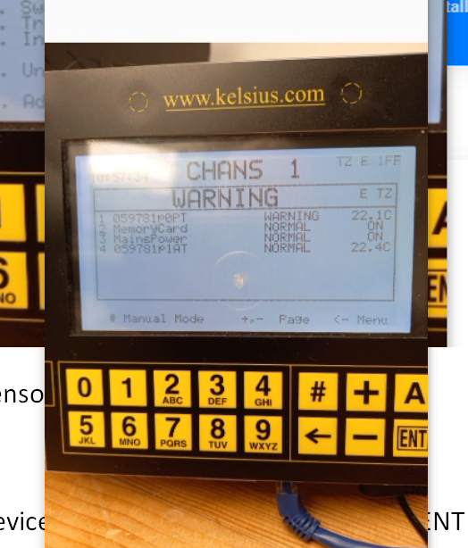

On NC Main Menu go to 9. Engineers Menu

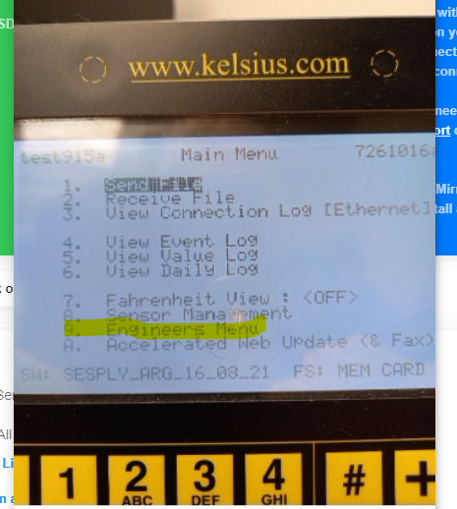

Enter PIN (usually current date i.e. 0810)

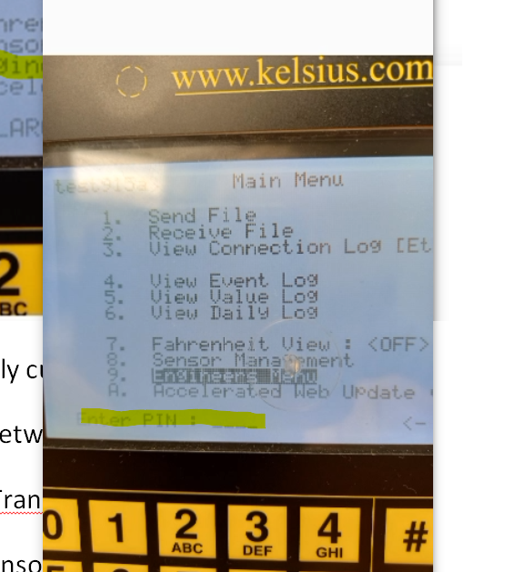

Go to 4. Slave Network management

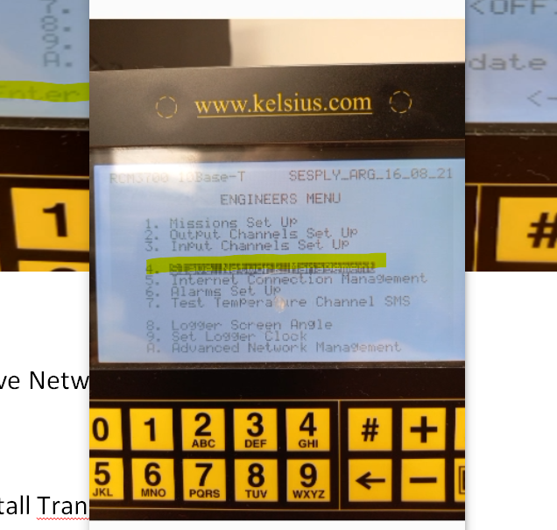

Go to 4. Install Tranztemp Device

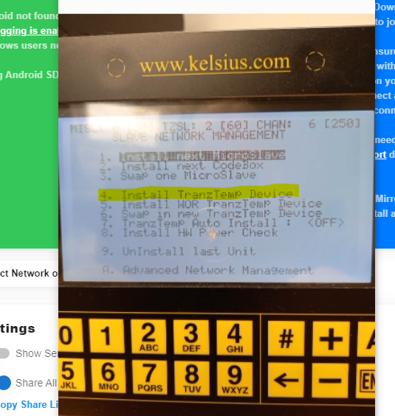

Activate your sensor

When Sensor device ID is displayed on screen press ENT to select

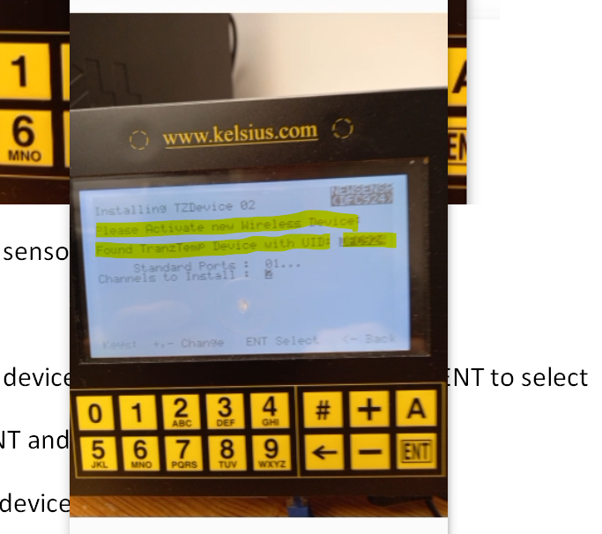

Then press ENT and any key to confirm

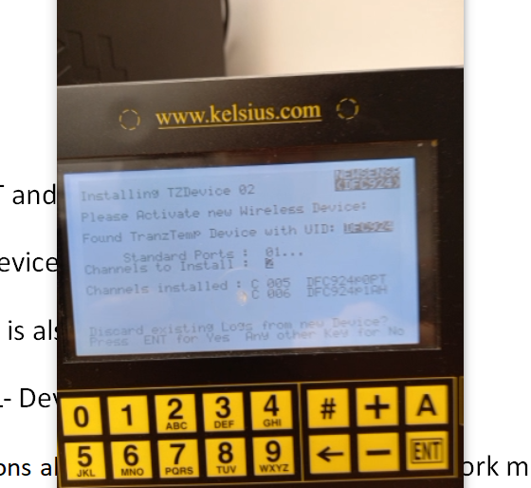

Confirm new device is now on main NC screen

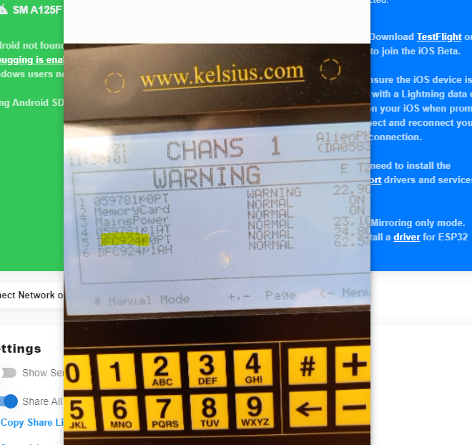

Confirm device is also on RV

TEST CASE 5.4 FINAL CHECKS- Confirm that channel of device can be changed.

Confirm current channel of device on *RV/Slave Network/ RF Network Devices*

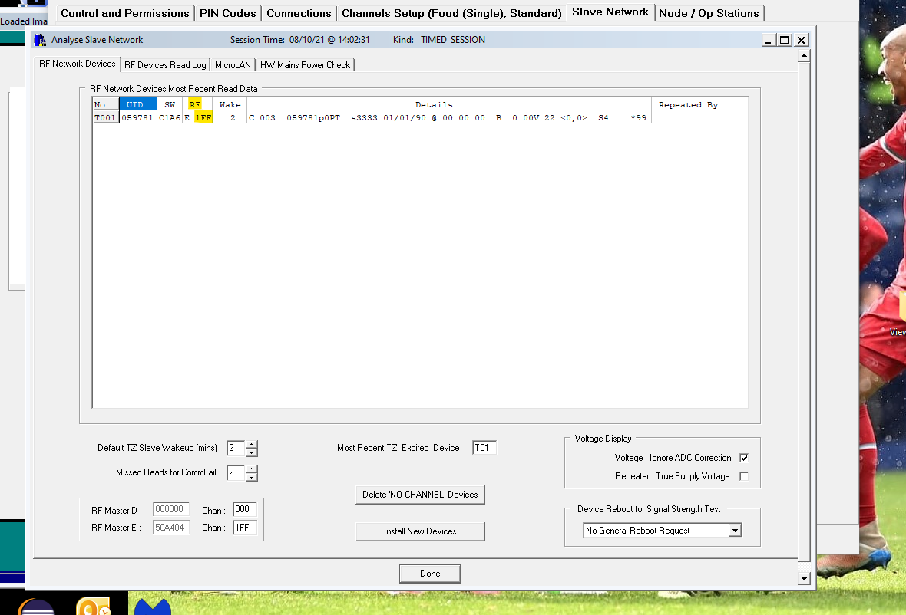

On NC go to Engineers Menu (see above)

Go to A. Advanced Network Management

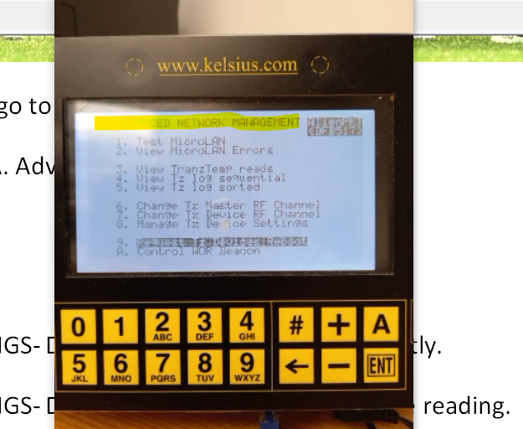

Go to 7. Change TZ Device RF Channel

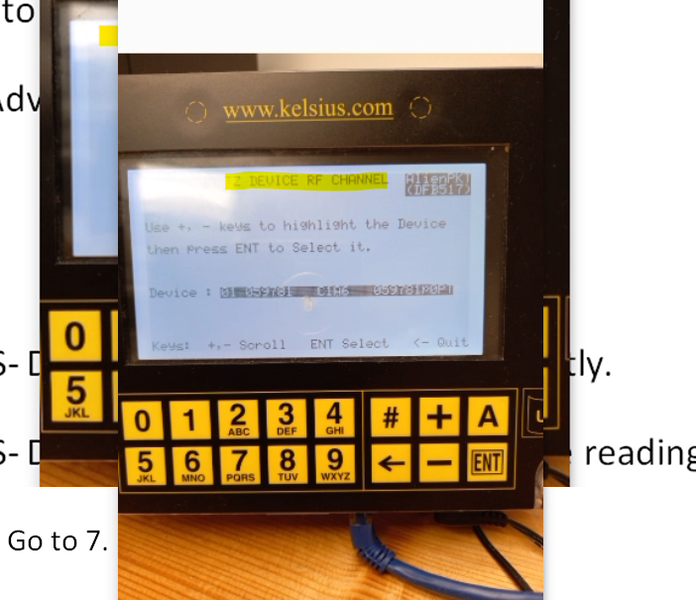

Scroll until the device is selected

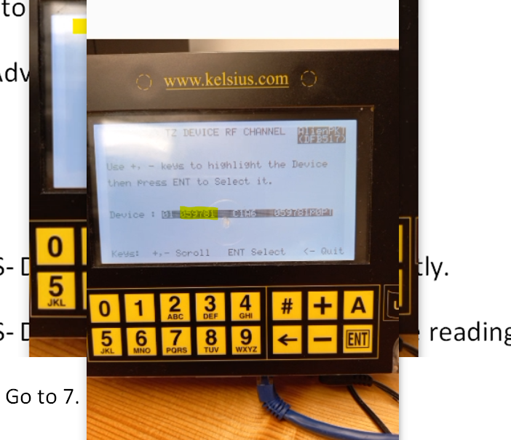

Press *ENT* to select the device

Use *Change* keys to scroll until you find the required channel.

Press A to accept the channel.

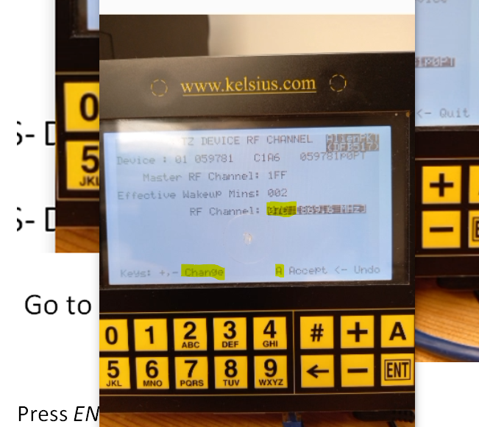

Press A to Apply changes

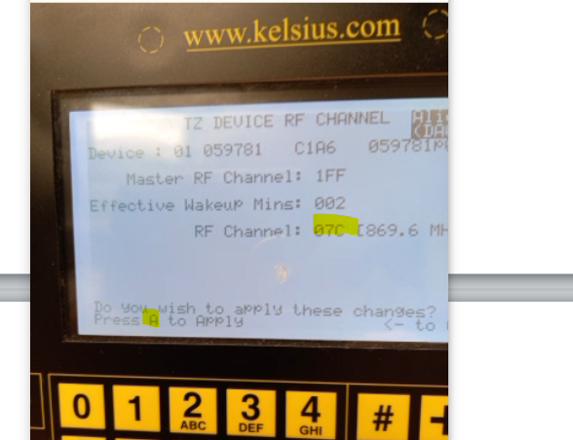

Press any key to continue

Activate the device to apply changes

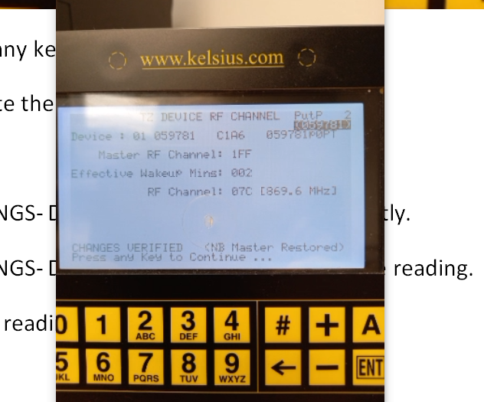

Verify change on RV

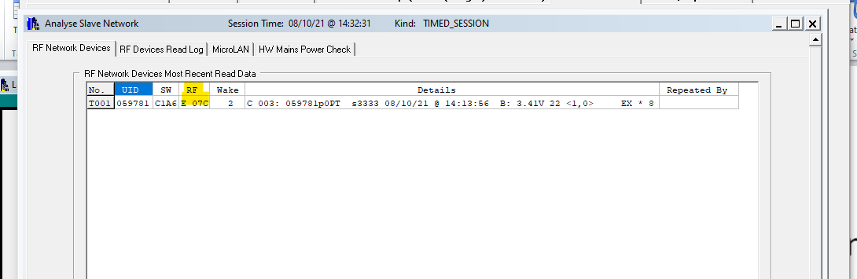

TEST CASE 5.5 FINAL CHECKS- Device uninstalls correctly – NC

Repeat instructions above until you reach 4. Slave Network management

Then press 9. Uninstall last unit

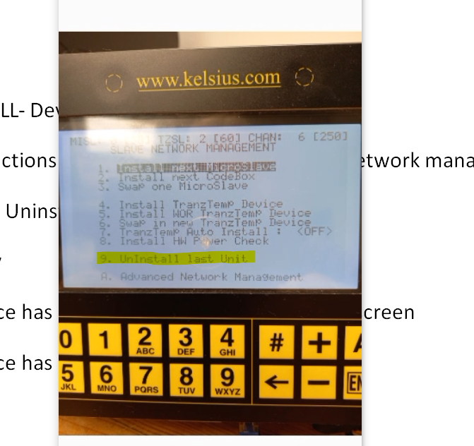

Press any key

Confirm device has now disappeared from main NC screen

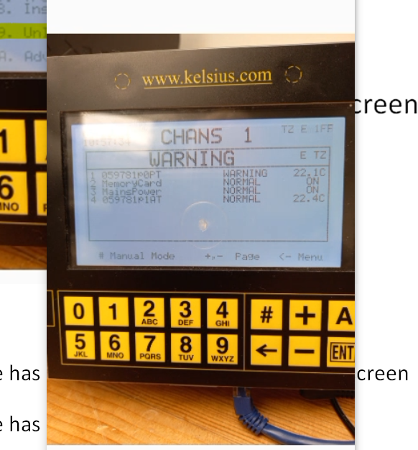

Confirm device has also disappeared from RV